

**Student Portal**

**Usability test plan**

**Facilitator: Sergiu Tripon**

**Participant: Pratiksha Vekaria**

**Version:** 1.0

**Writer:** Sergiu Tripon

**Date:** 04/04/2015

Contents

Introduction 3

Test cases 4

Results 34

# Introduction

This document details the events occurred during the usability testing phase of the Student Portal application. It is made out of 5 main chapters. The first chapter showcases the test cases that were created and used by the participant to test the application’s usability. The results are shown in the second chapter.

# Test cases

**Recording URL:** <https://student-portal.co.uk/usability-testing/?video=full-video>

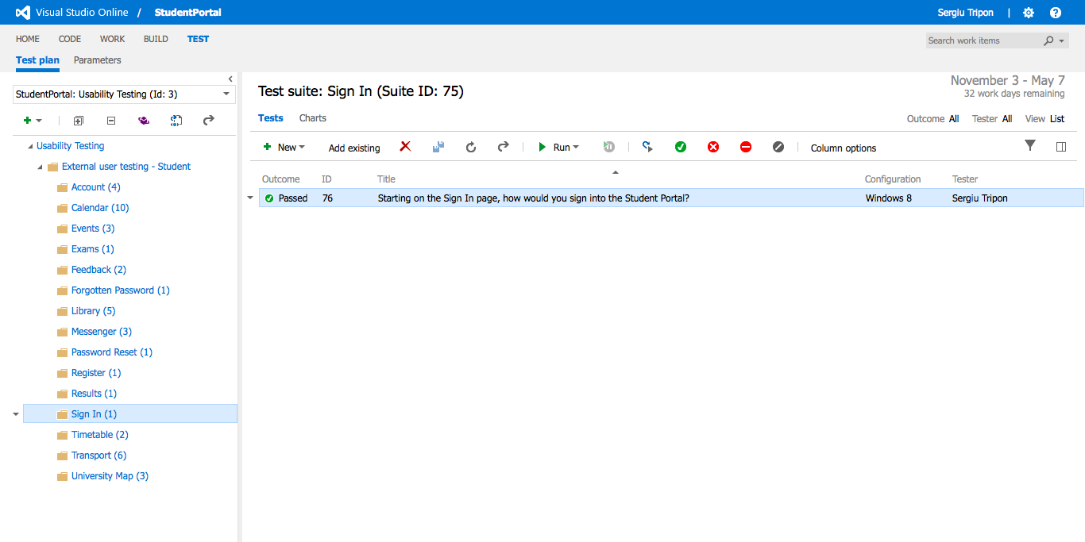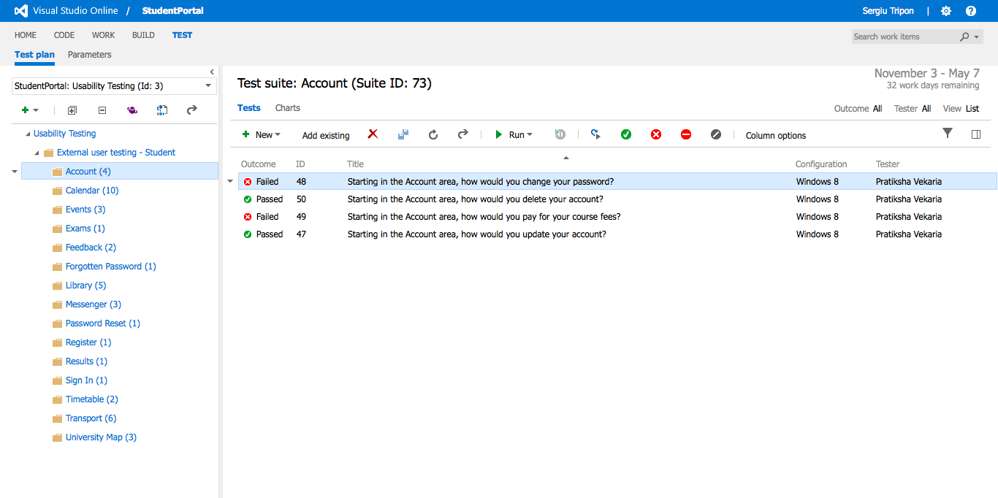

**Test cases - Overview**

**Recording URL:** <https://student-portal.co.uk/usability-testing/?video=sign-in>



**Sign In** - overview of the test case(s)

**Recording URL:** <https://student-portal.co.uk/usability-testing/?video=sign-in>

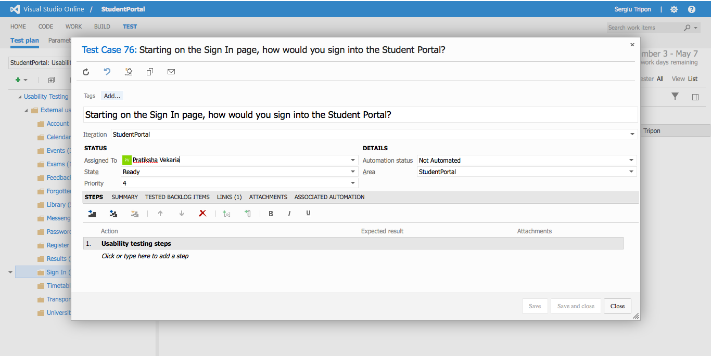

**Sign In** - detailed view of test case

**Recording URL:** <https://student-portal.co.uk/usability-testing/?video=register>

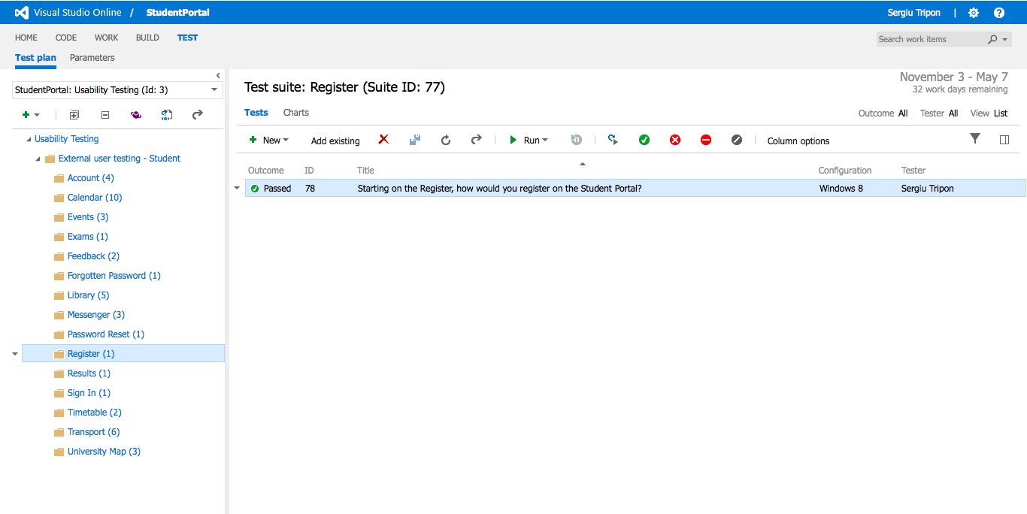

**Register** - overview of the test case(s)

**Recording URL:** <https://student-portal.co.uk/usability-testing/?video=register>

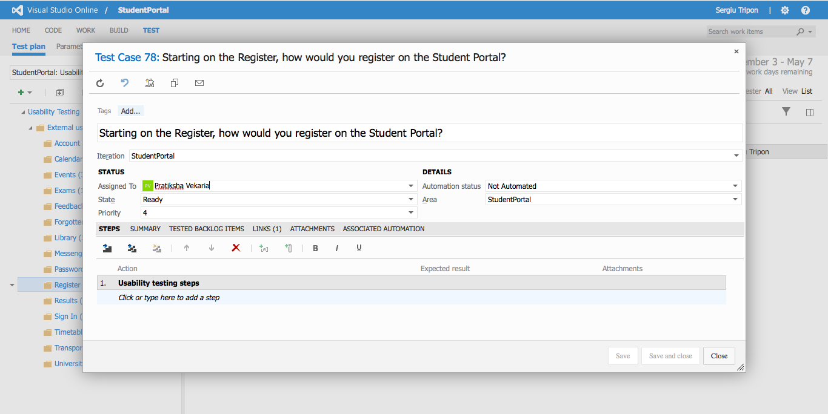

**Register** - detailed view of a test case

**Recording URL:** <https://student-portal.co.uk/usability-testing/?video=forgotten-password>

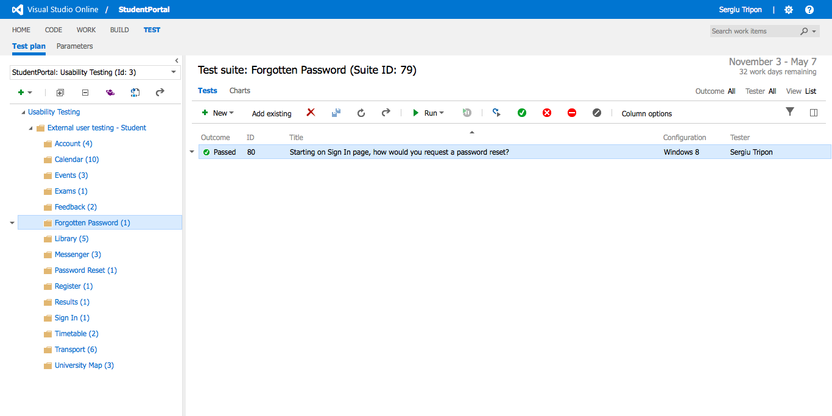

**Forgotten password** - overview of the test case(s)

**Recording URL:** <https://student-portal.co.uk/usability-testing/?video=forgotten-password>

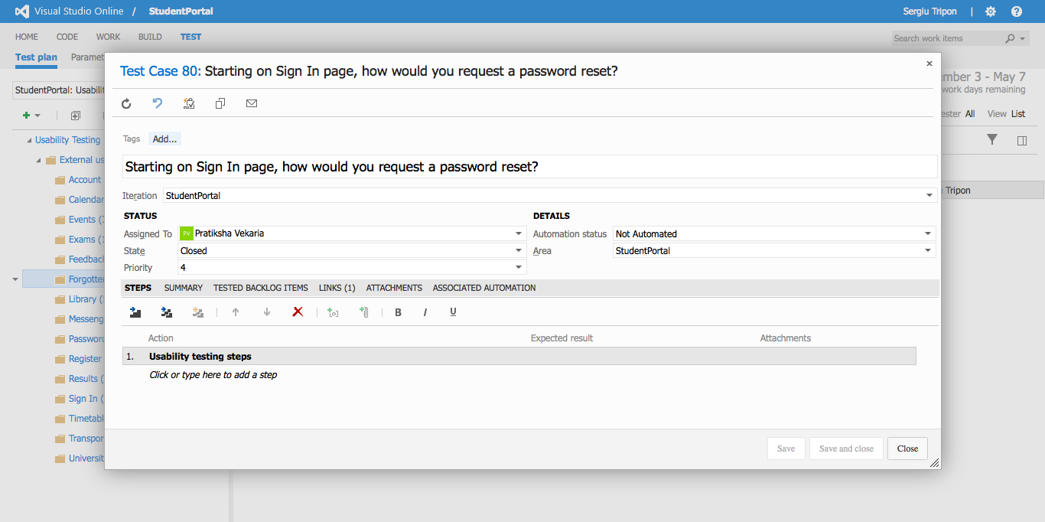

**Forgotten password** - detailed view of a test case

**Recording URL:** <https://student-portal.co.uk/usability-testing/?video=password-reset>

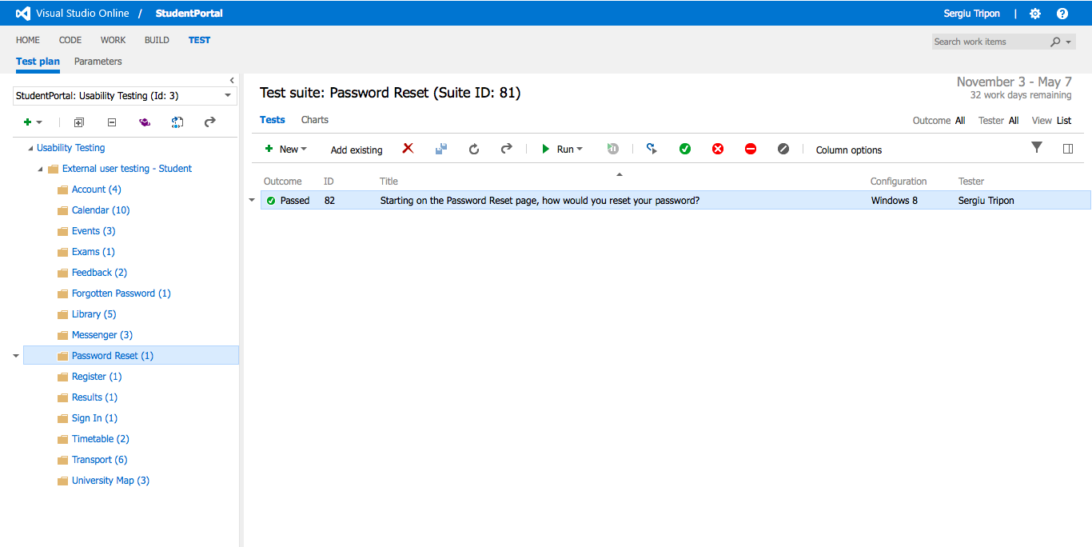

**Password reset** - overview of the test case(s)

**Recording URL:** <https://student-portal.co.uk/usability-testing/?video=password-reset>

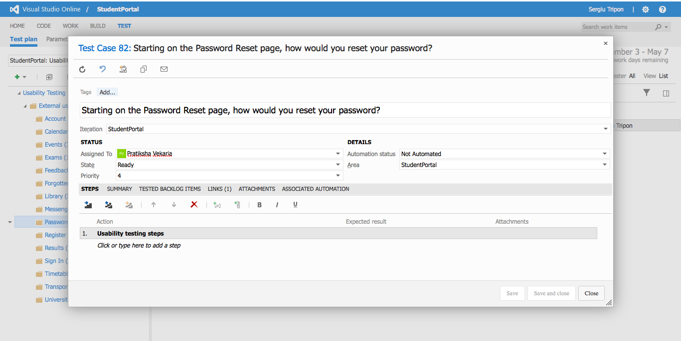

**Password reset** - detailed view of a test case

**Recording URL:** <https://student-portal.co.uk/usability-testing/?video=timetable>

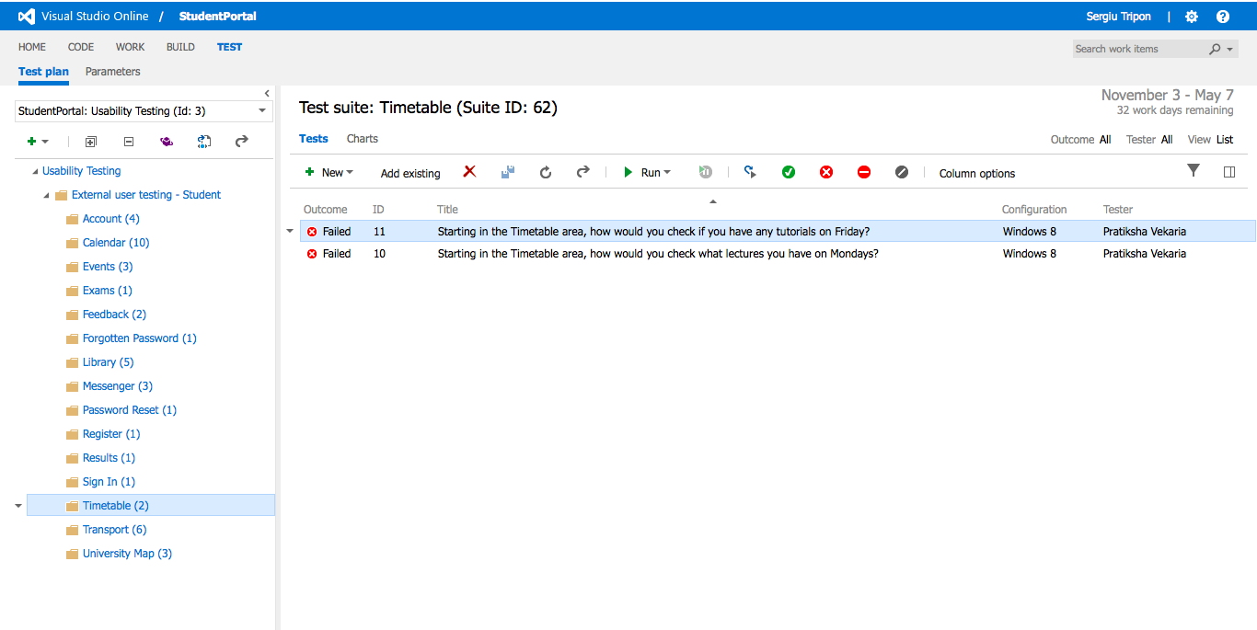

**Timetable** - overview of the test case(s)

**Recording URL:** <https://student-portal.co.uk/usability-testing/?video=timetable>

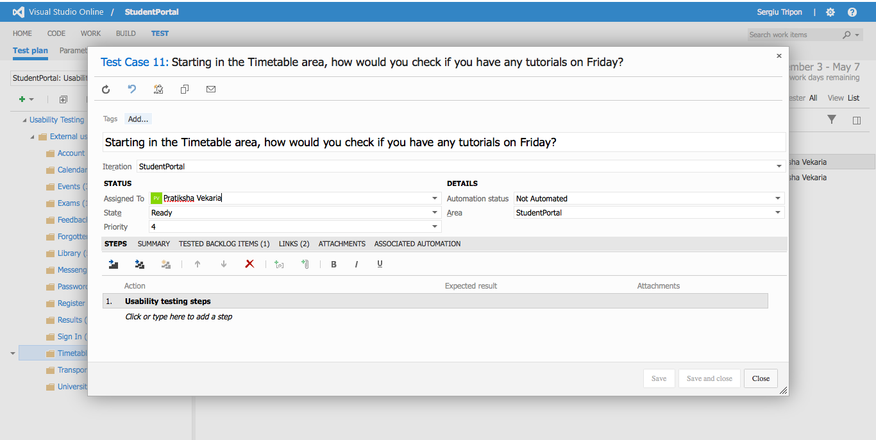

**Timetable** - detailed view of a test case

**Recording URL:** <https://student-portal.co.uk/usability-testing/?video=timetable>

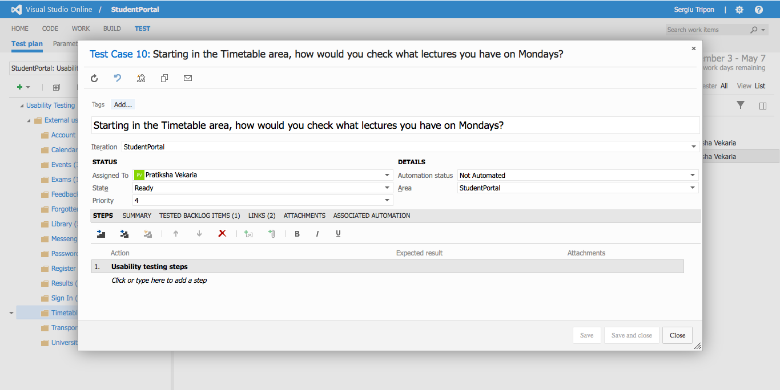

**Timetable** - detailed view of a test case

**Recording URL:** <https://student-portal.co.uk/usability-testing/?video=exams>

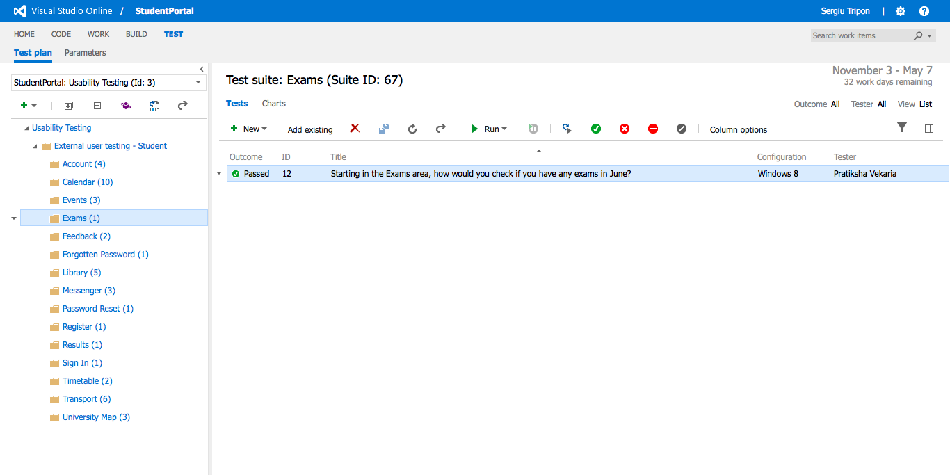

**Exams** - overview of the test case(s)

**Recording URL:** <https://student-portal.co.uk/usability-testing/?video=exams>

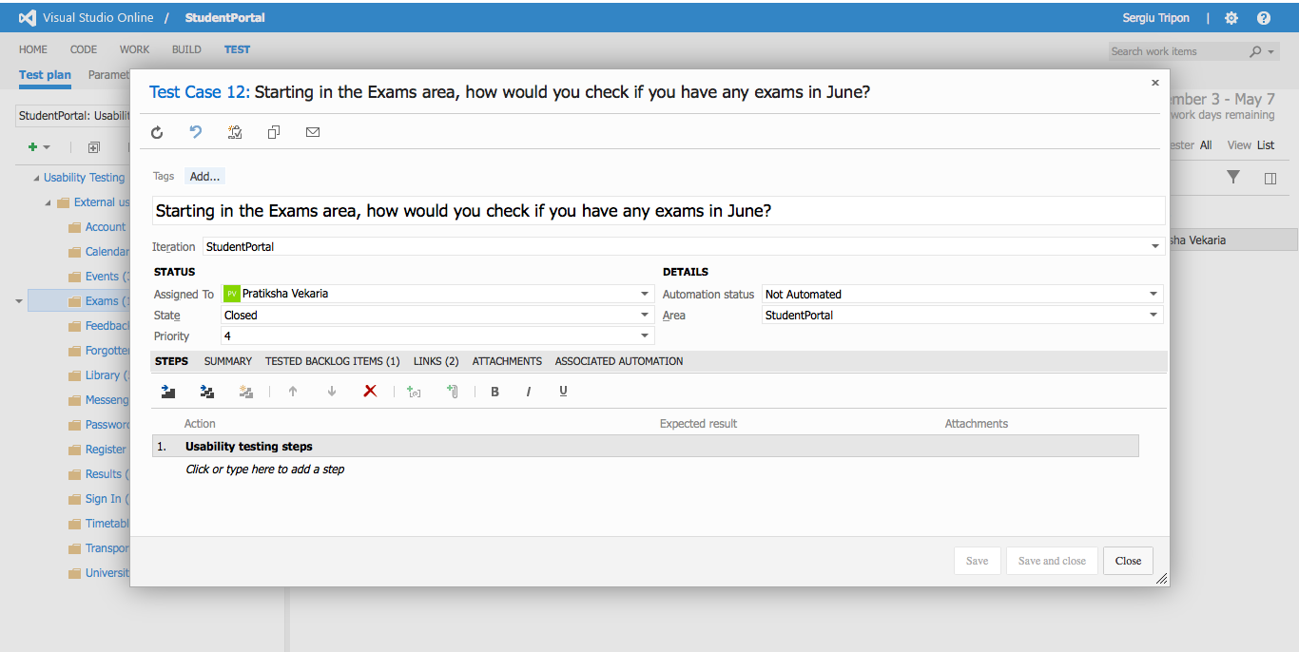

**Exams** - detailed view of a test case

**Recording URL:** <https://student-portal.co.uk/usability-testing/?video=results>

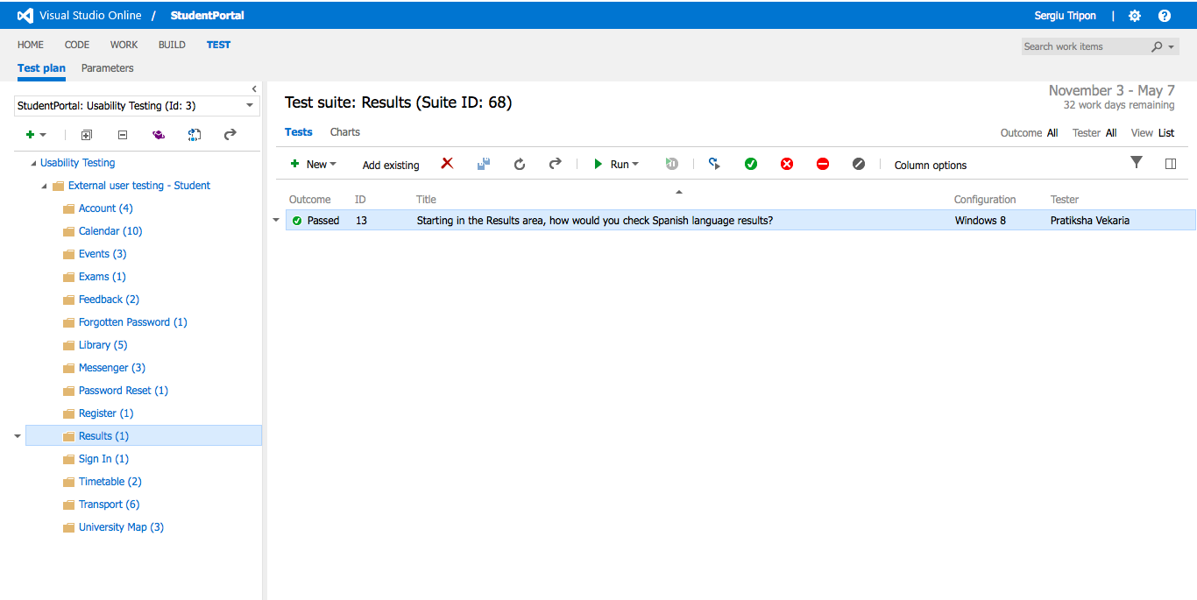

**Results** - overview of the test case(s)

**Recording URL:** <https://student-portal.co.uk/usability-testing/?video=results>

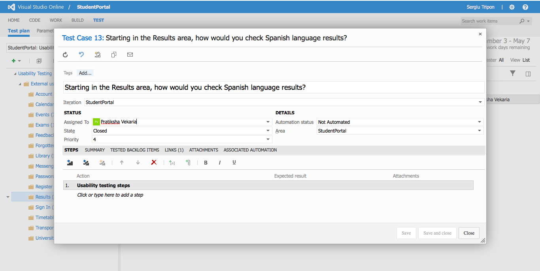

**Results** - detailed view of a test case

**Recording URL:** <https://student-portal.co.uk/usability-testing/?video=transport>

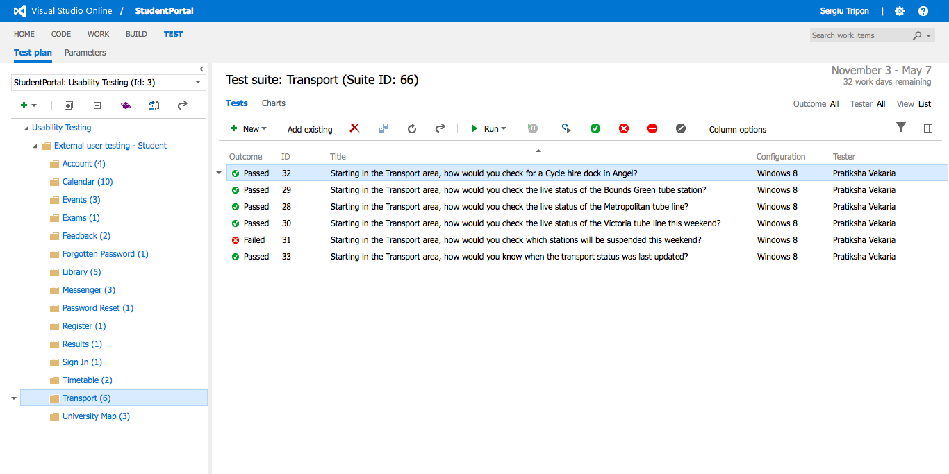

**Transport** - overview of the test case(s)

**Recording URL:** <https://student-portal.co.uk/usability-testing/?video=transport>

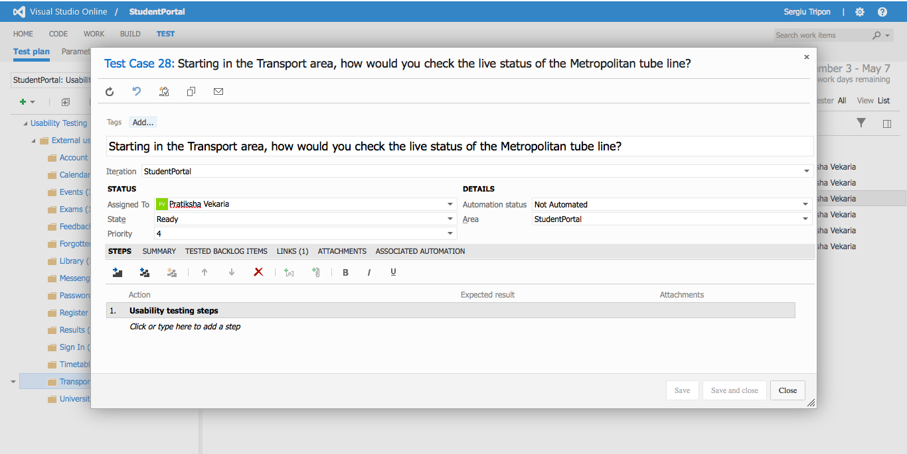

**Transport** - detailed view of a test case

**Recording URL:** <https://student-portal.co.uk/usability-testing/?video=transport>

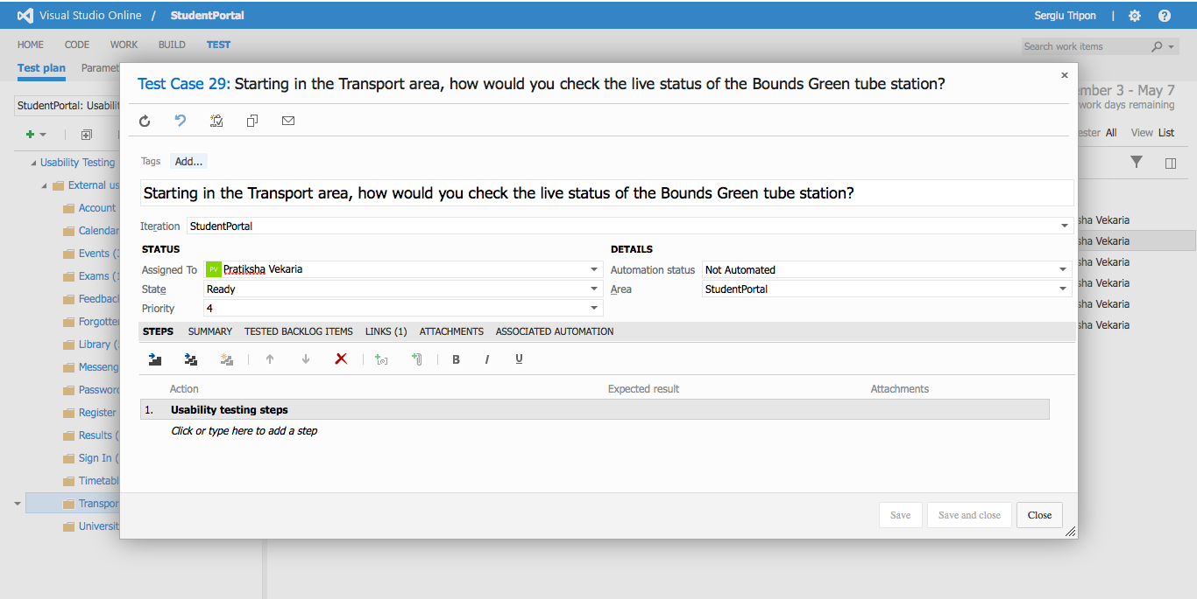

**Transport** - detailed view of a test case

**Recording URL:** <https://student-portal.co.uk/usability-testing/?video=timetable>

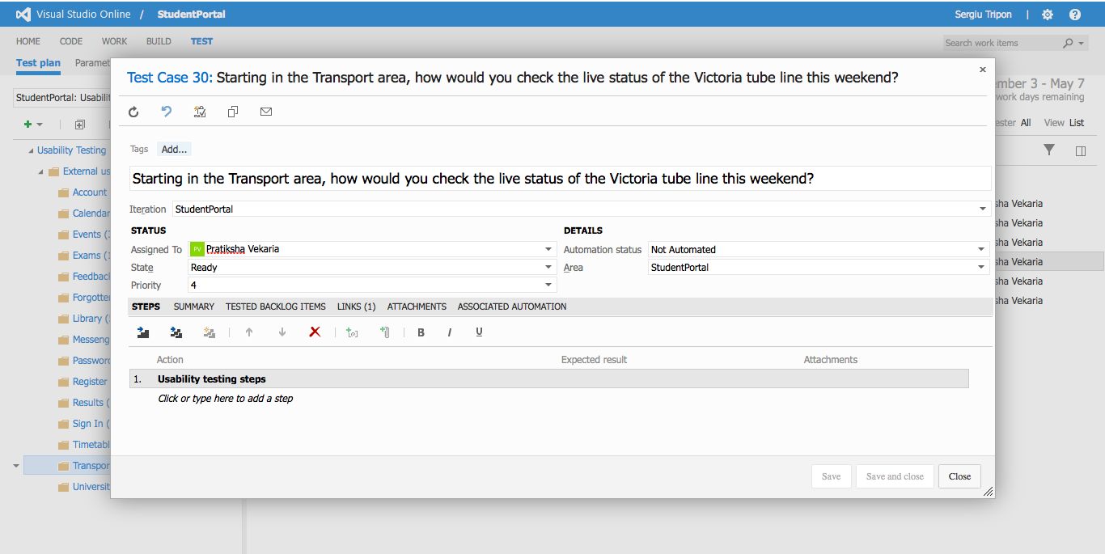

**Transport** - detailed view of a test case

**Recording URL:** <https://student-portal.co.uk/usability-testing/?video=transport>

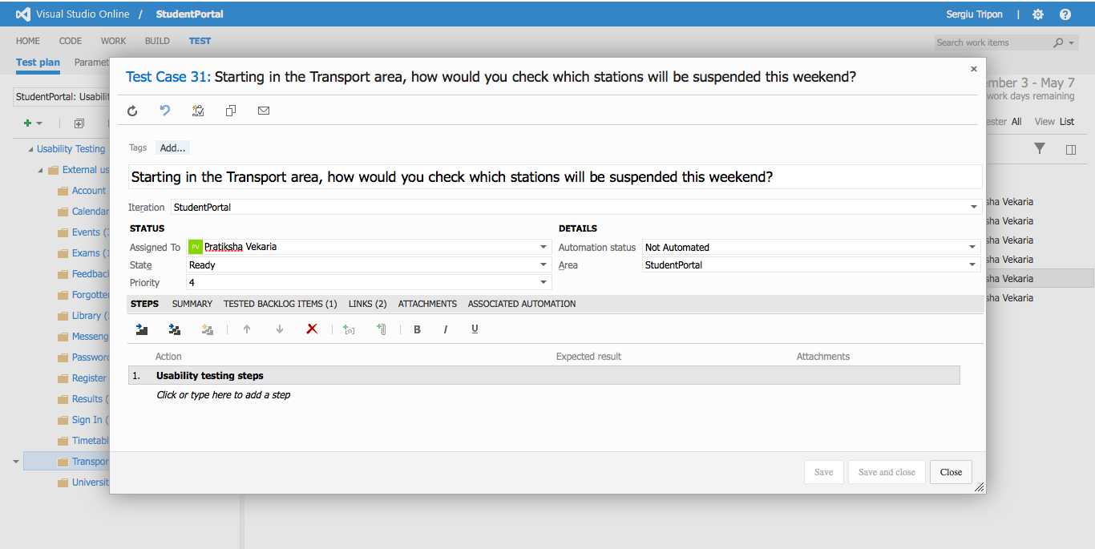

**Transport** - detailed view of a test case

**Recording URL:** <https://student-portal.co.uk/usability-testing/?video=transport>

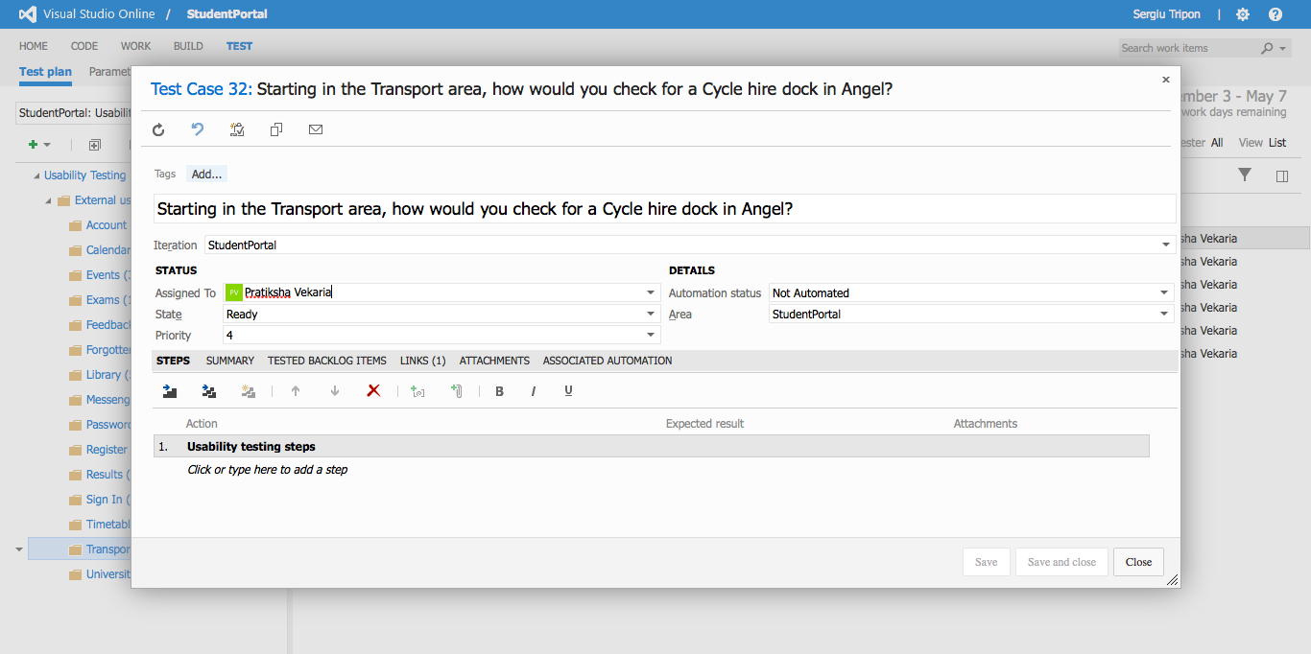

**Transport** - detailed view of a test case

**Recording URL:** <https://student-portal.co.uk/usability-testing/?video=transport>

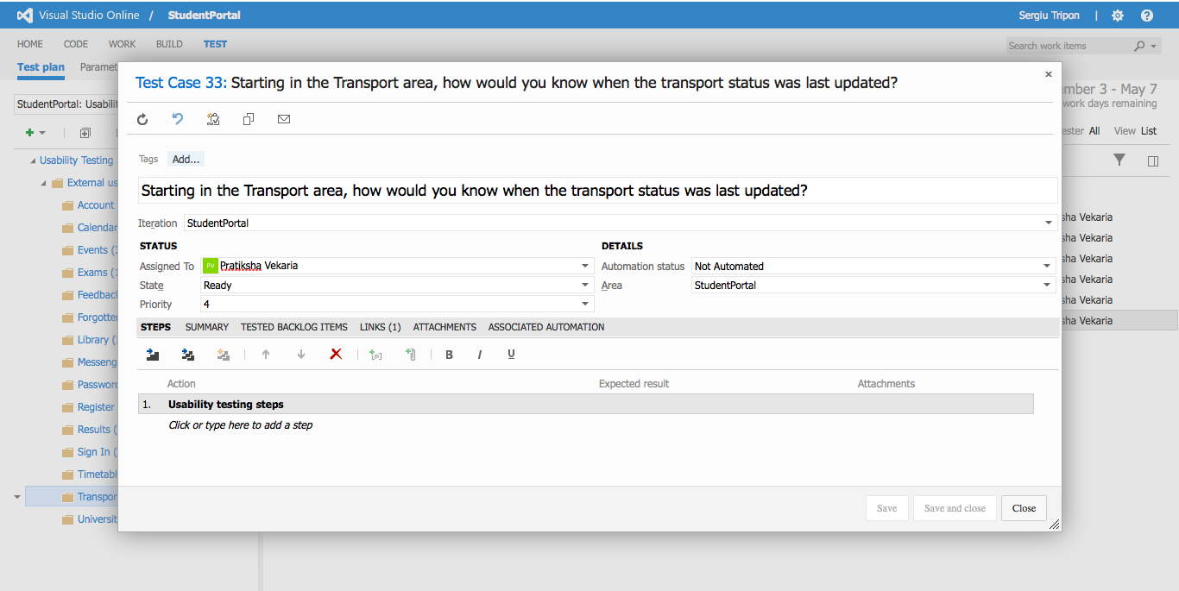

**Transport** - detailed view of a test case

**Recording URL:** <https://student-portal.co.uk/usability-testing/?video=library>

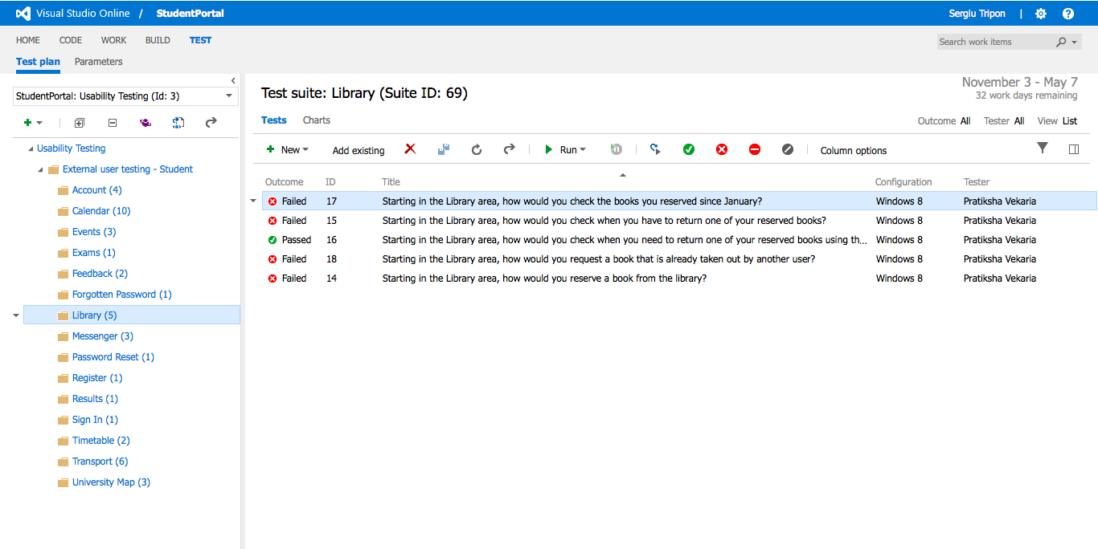

**Library** - overview of the test case(s)

**Recording URL:** <https://student-portal.co.uk/usability-testing/?video=library>

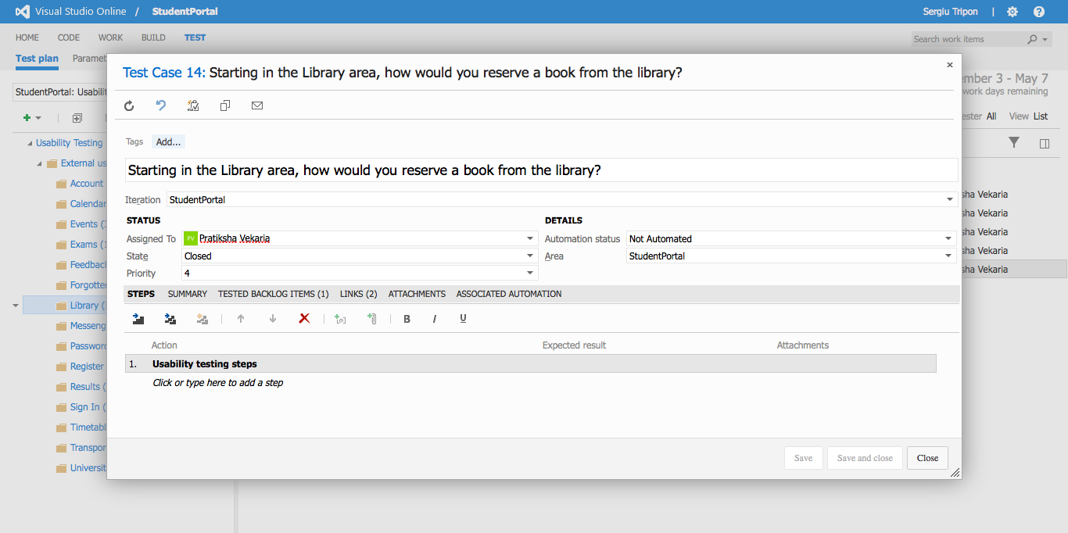

**Library** - detailed view of a test case

**Recording URL:** <https://student-portal.co.uk/usability-testing/?video=library>

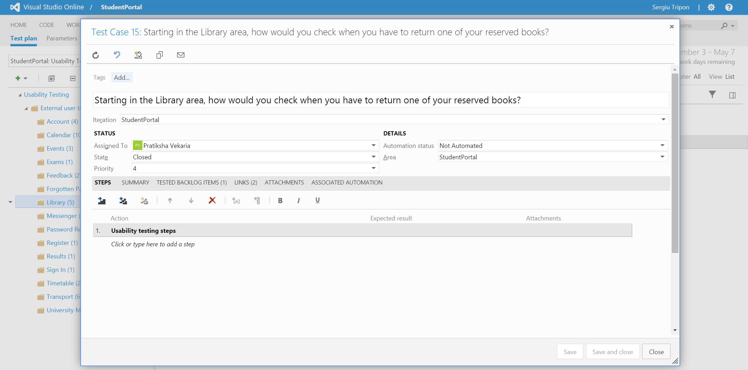

**Library** - detailed view of a test case

**Recording URL:** <https://student-portal.co.uk/usability-testing/?video=library>

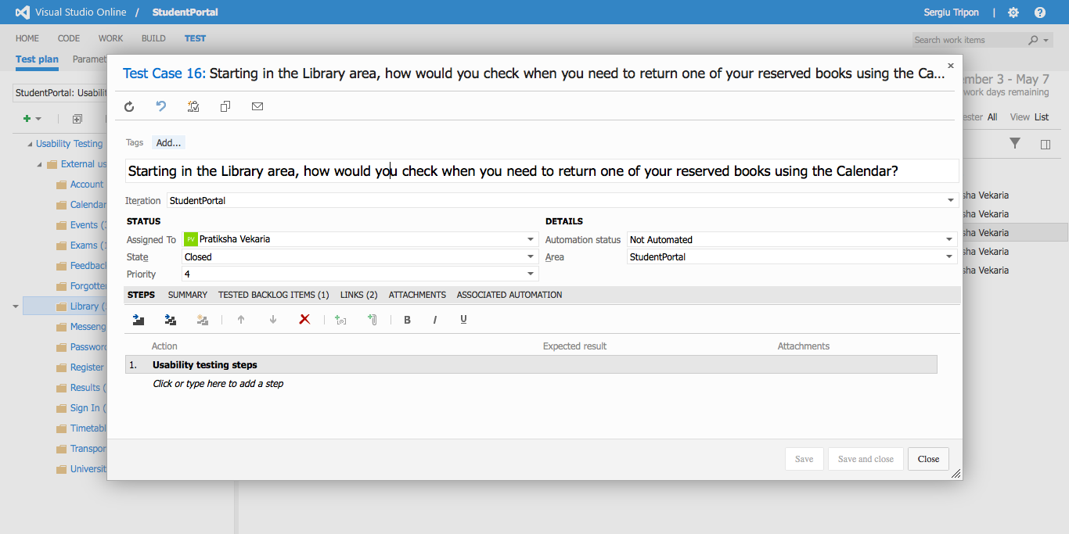

**Library** - detailed view of a test case

**Recording URL:** <https://student-portal.co.uk/usability-testing/?video=library>

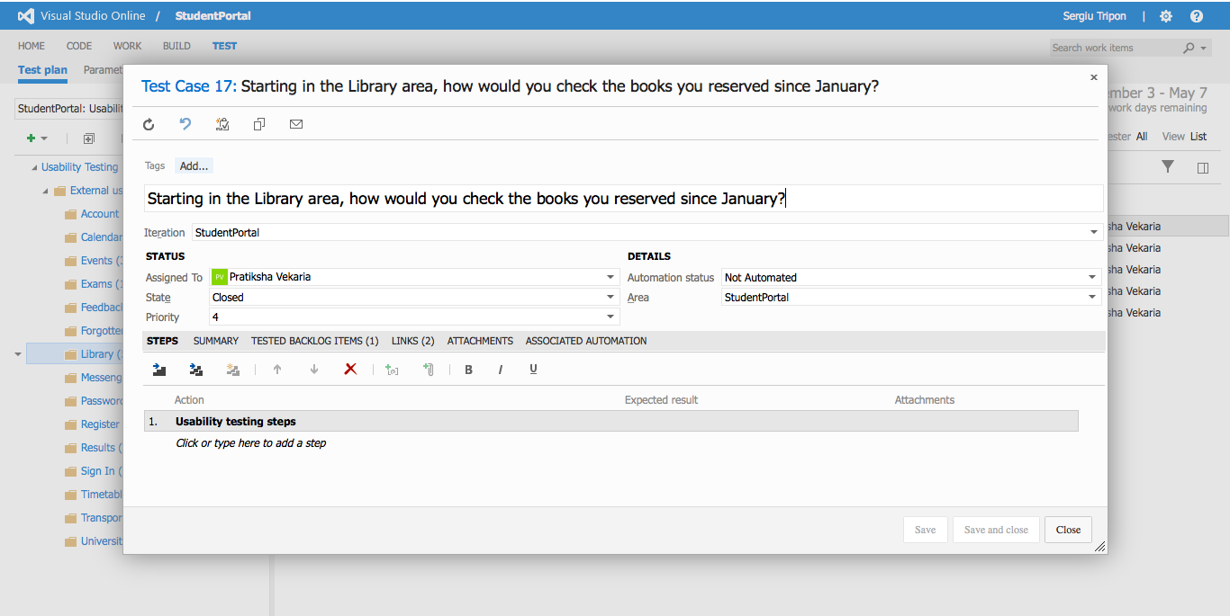

**Library** - detailed view of a test case

**Recording URL:** <https://student-portal.co.uk/usability-testing/?video=library>

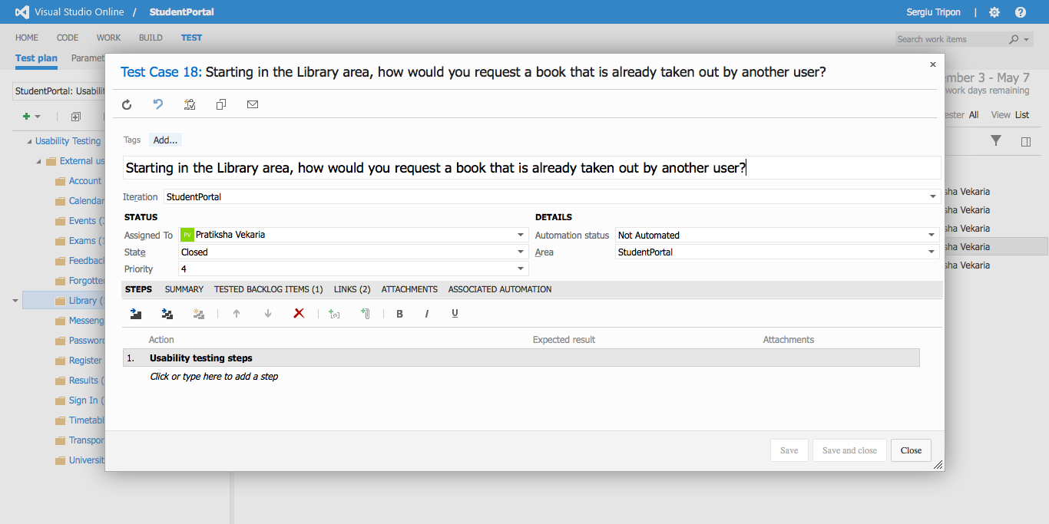

**Library** - detailed view of a test case

**Recording URL:** <https://student-portal.co.uk/usability-testing/?video=calendar>

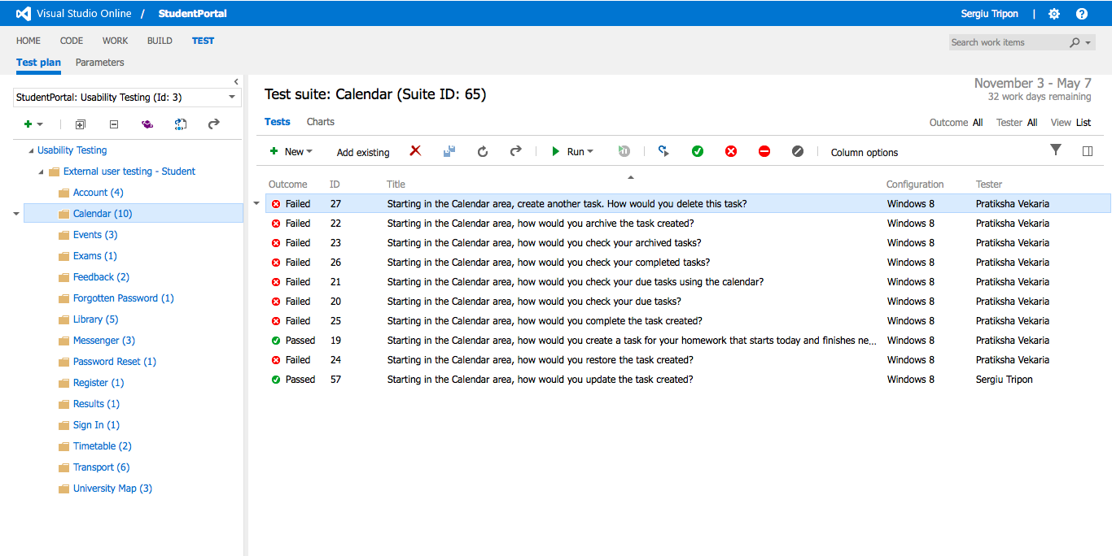

**Calendar** - overview of the test case(s)

**Recording URL:** <https://student-portal.co.uk/usability-testing/?video=calendar>

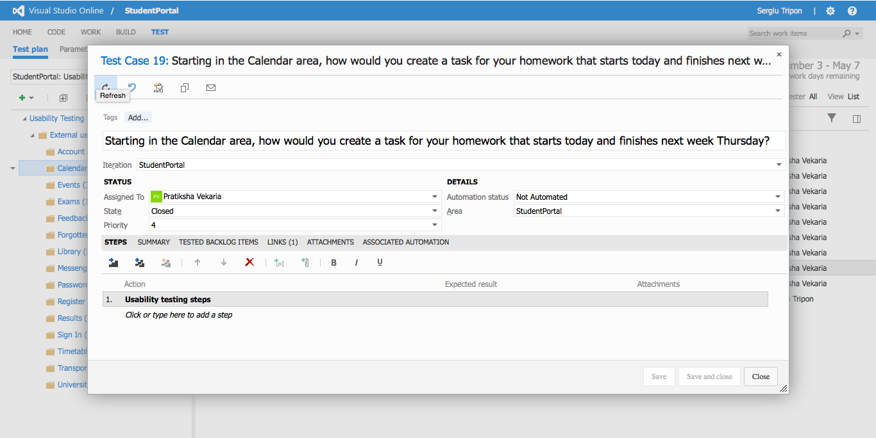

**Calendar** - detailed view of a test case

**Recording URL:** <https://student-portal.co.uk/usability-testing/?video=calendar>

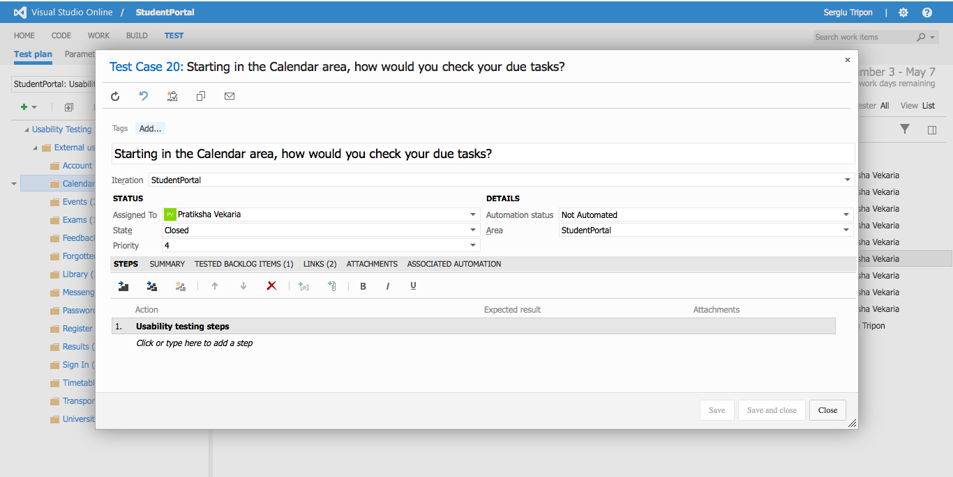

**Calendar** - detailed view of a test case

**Recording URL:** <https://student-portal.co.uk/usability-testing/?video=calendar>

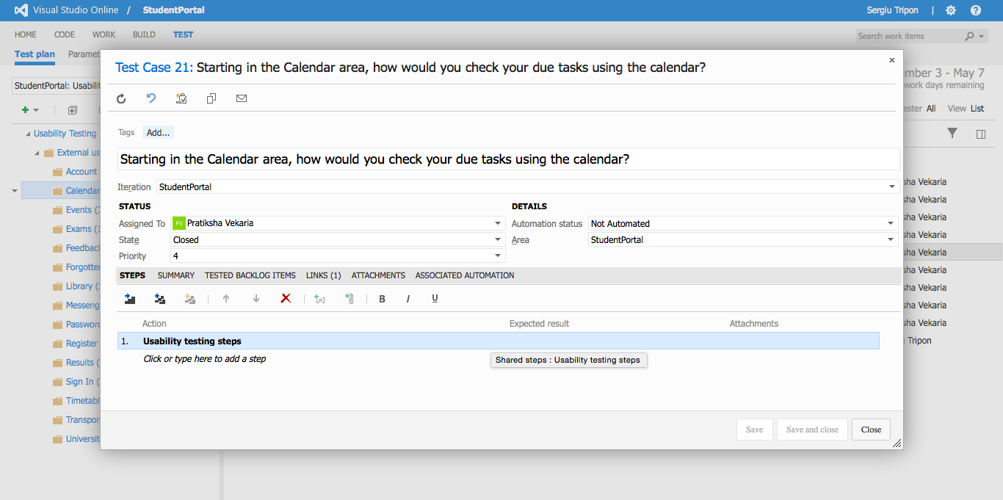

**Calendar** - detailed view of a test case

**Recording URL:** <https://student-portal.co.uk/usability-testing/?video=calendar>

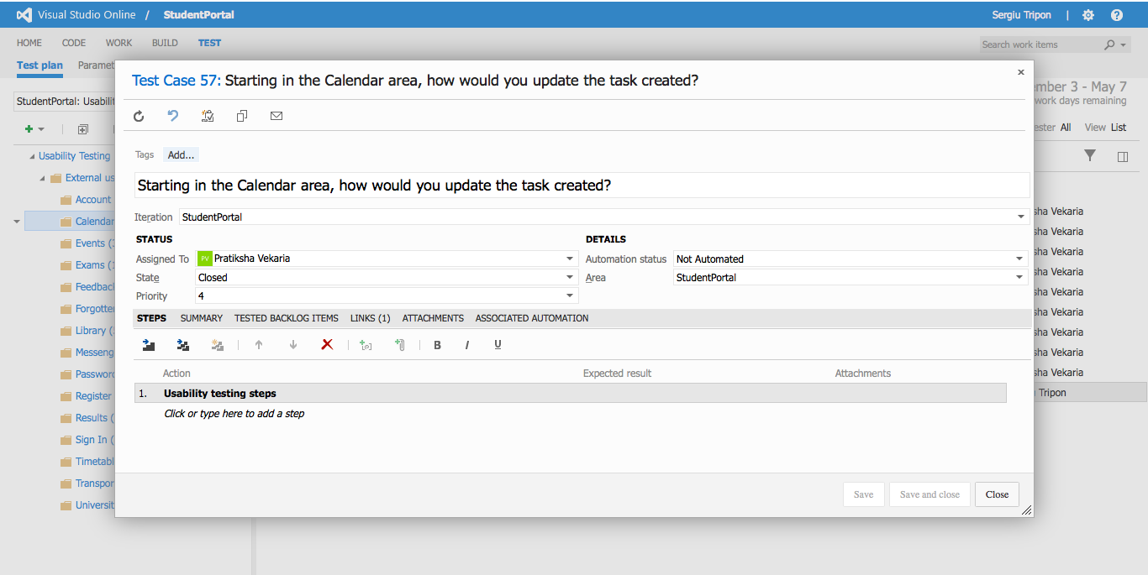

**Calendar** - detailed view of a test case

**Recording URL:** <https://student-portal.co.uk/usability-testing/?video=calendar>

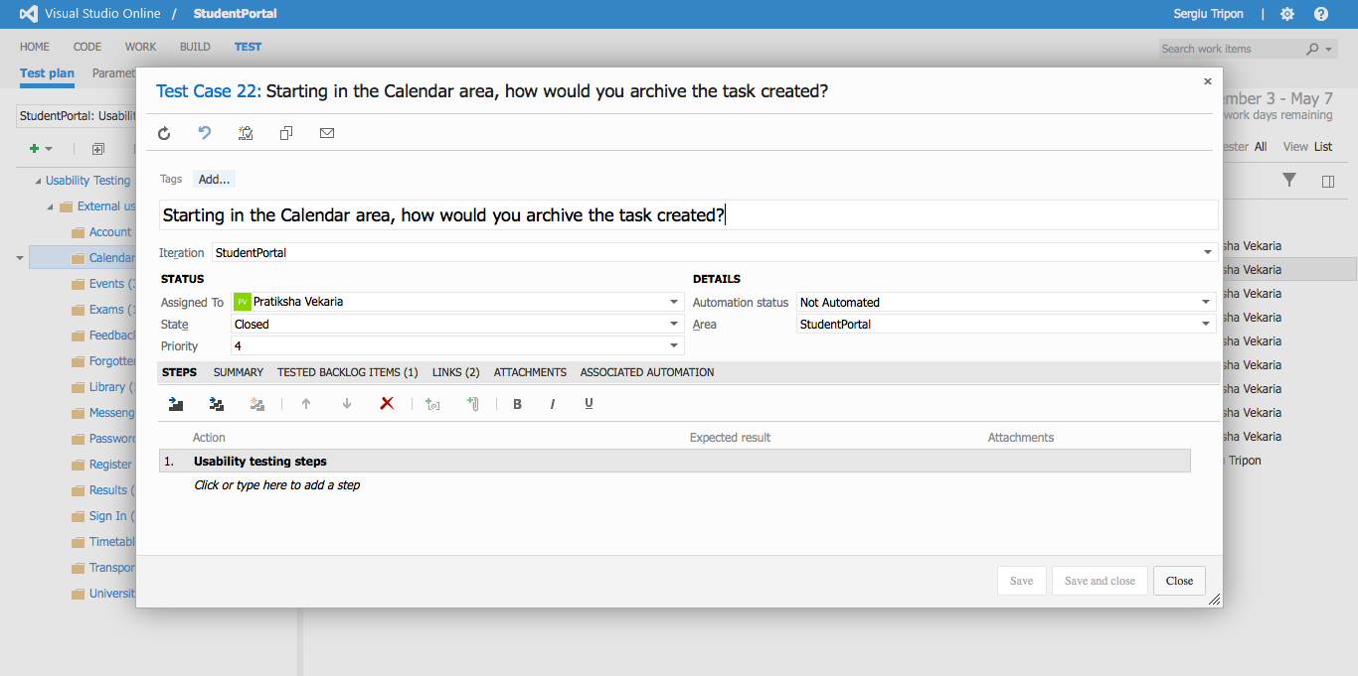

**Calendar** - detailed view of a test case

**Recording URL:** <https://student-portal.co.uk/usability-testing/?video=calendar>

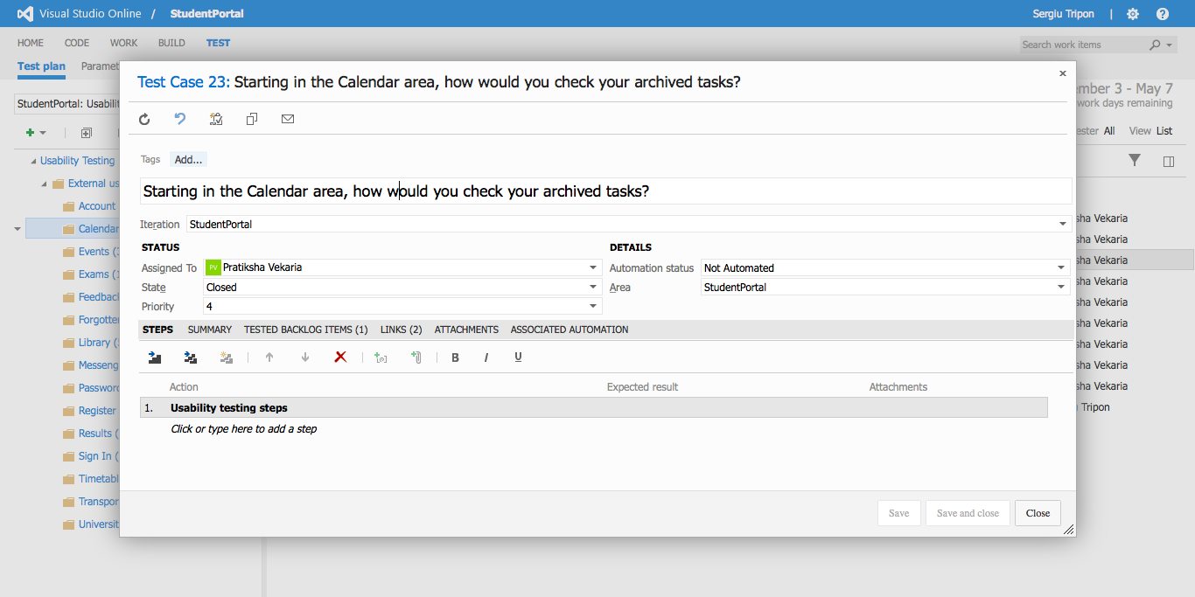

**Calendar** - detailed view of a test case

**Recording URL:** <https://student-portal.co.uk/usability-testing/?video=calendar>

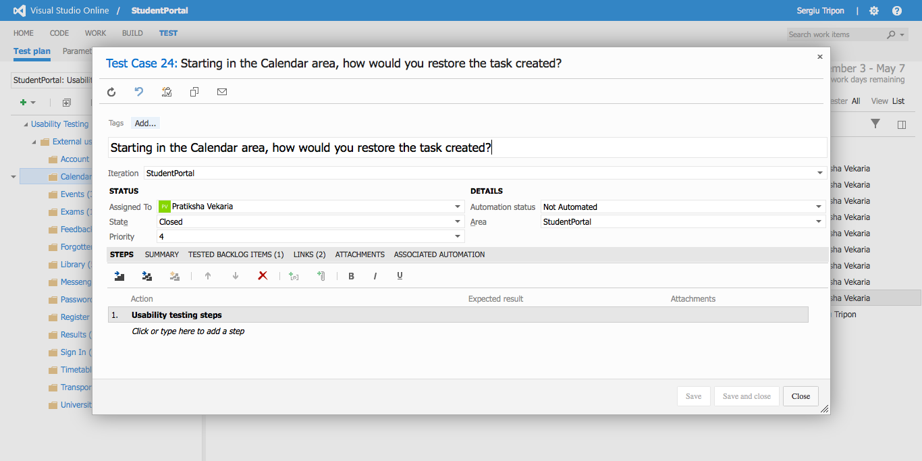

**Calendar** - detailed view of a test case

**Recording URL:** <https://student-portal.co.uk/usability-testing/?video=calendar>

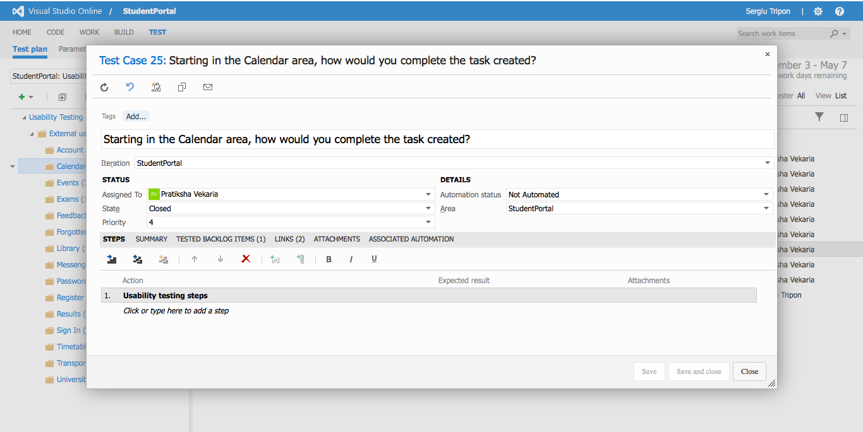

**Calendar** - detailed view of a test case

**Recording URL:** <https://student-portal.co.uk/usability-testing/?video=calendar>

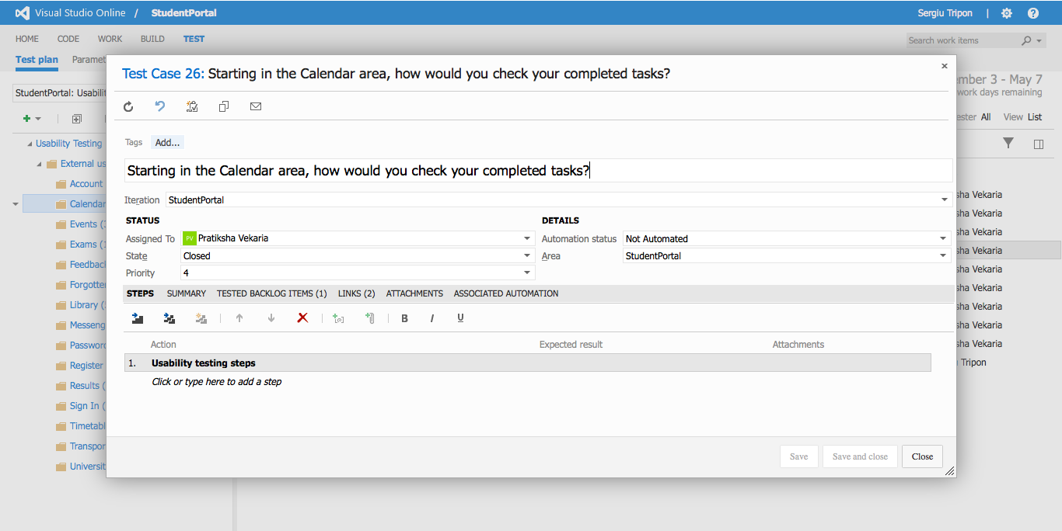

**Calendar** - detailed view of a test case

**Recording URL:** <https://student-portal.co.uk/usability-testing/?video=calendar>

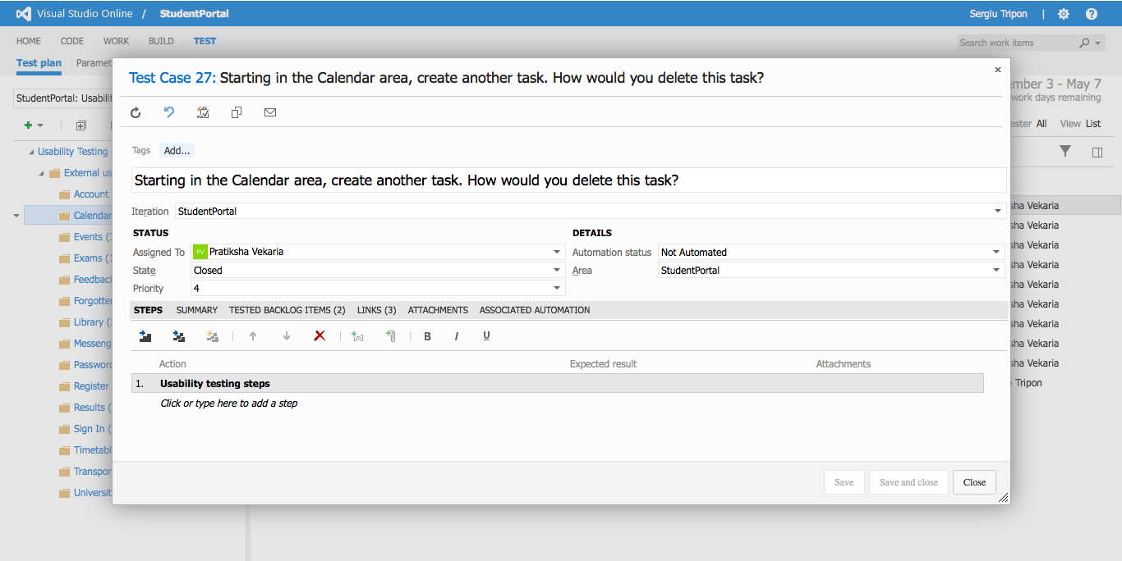

**Calendar** - detailed view of a test case

**Recording URL:** <https://student-portal.co.uk/usability-testing/?video=university-map>

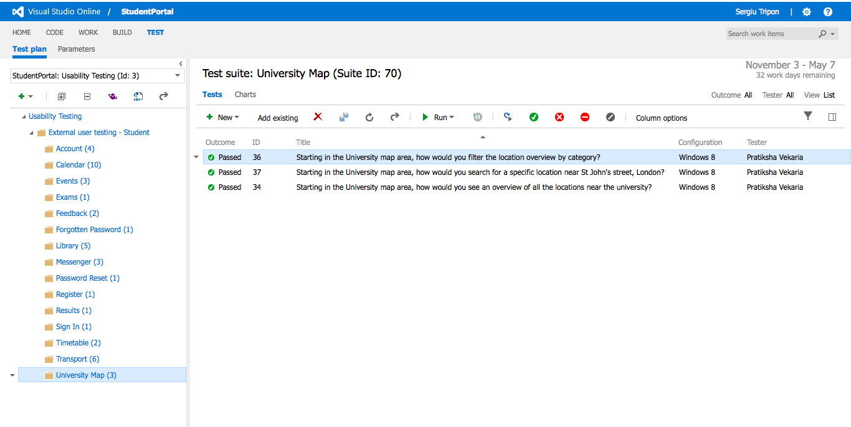

**University Map** - overview of the test case(s)

**Recording URL:** <https://student-portal.co.uk/usability-testing/?video=university-map>

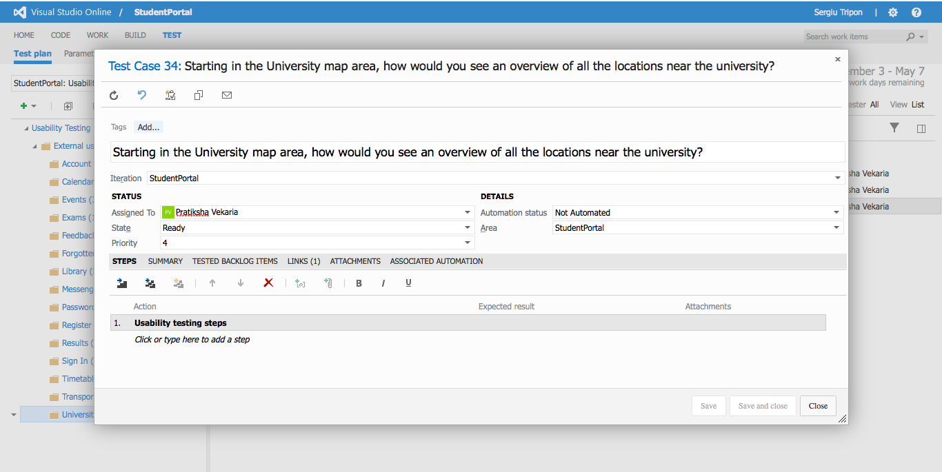

**University Map** - detailed view of a test case

**Recording URL:** <https://student-portal.co.uk/usability-testing/?video=university-map>

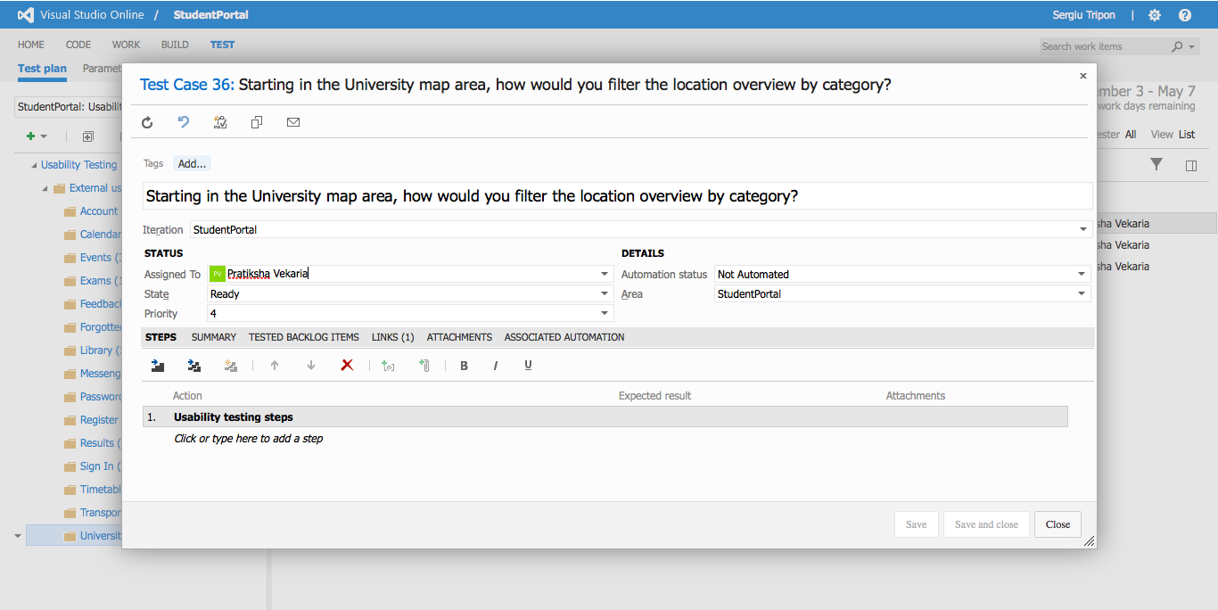

**University Map** - detailed view of a test case

**Recording URL:** <https://student-portal.co.uk/usability-testing/?video=university-map>

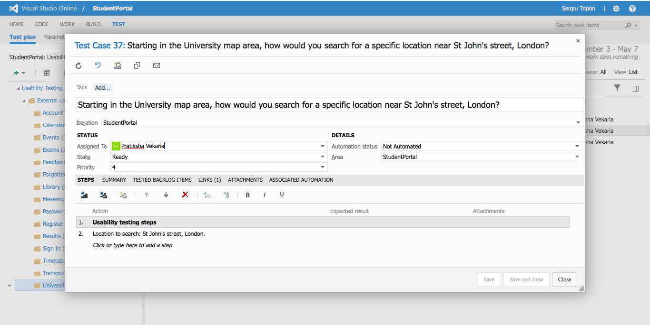

**University Map** - detailed view of a test case

**Recording URL:** <https://student-portal.co.uk/usability-testing/?video=events>

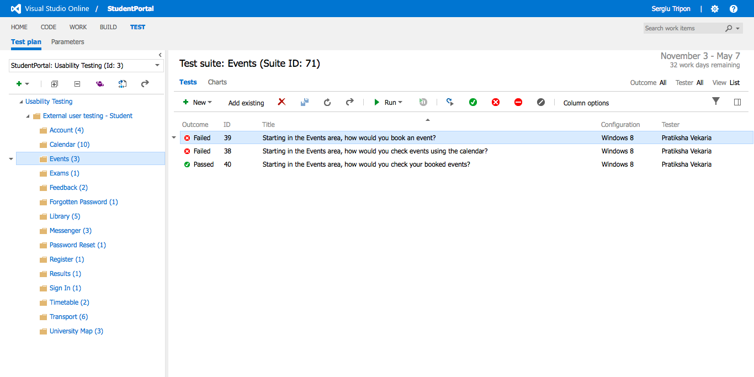

**Events** - overview of the test case(s)

**Recording URL:** <https://student-portal.co.uk/usability-testing/?video=events>

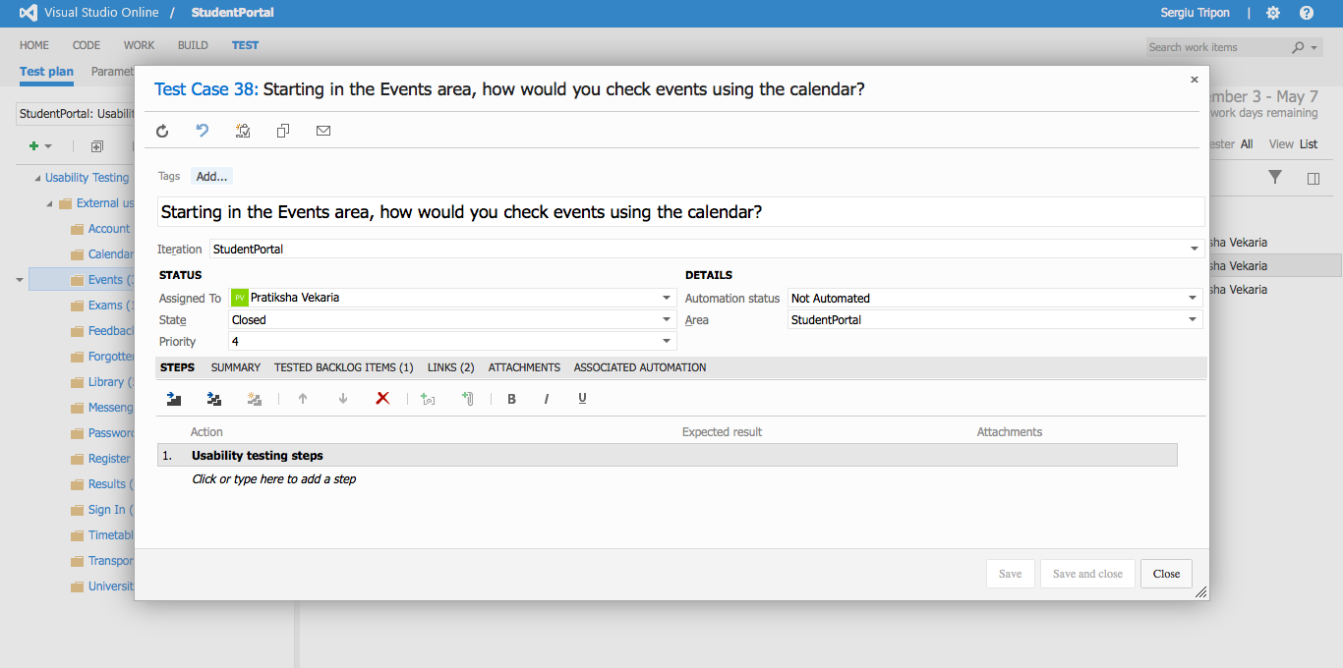

**Events** - detailed view of a test case

**Recording URL:** <https://student-portal.co.uk/usability-testing/?video=events>

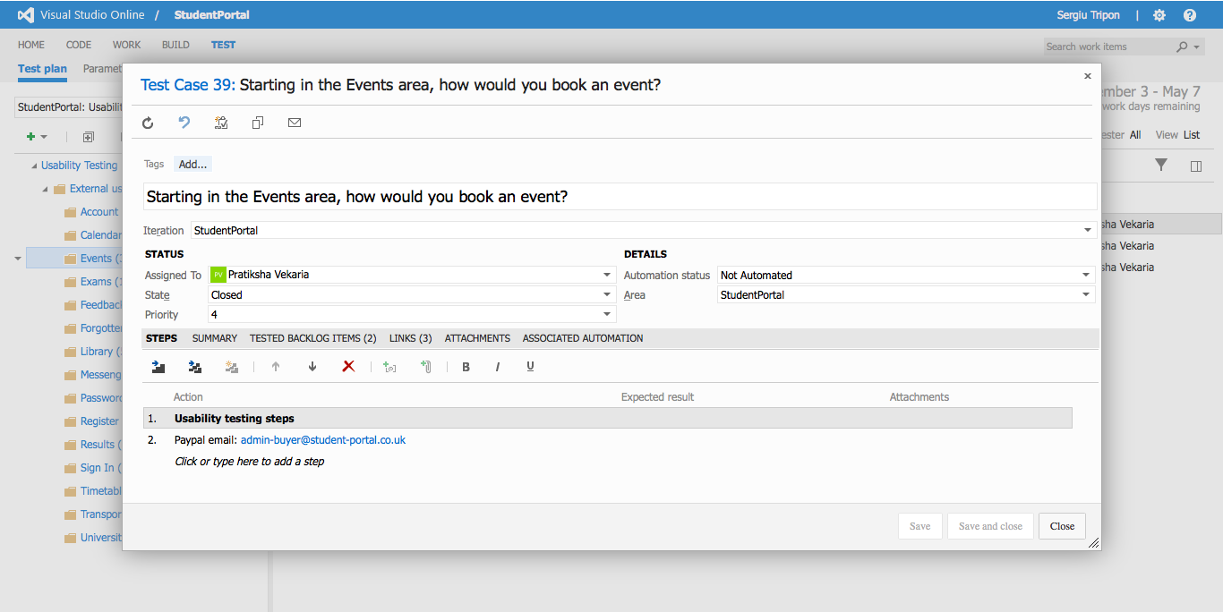

**Events** - detailed view of a test case

**Recording URL:** <https://student-portal.co.uk/usability-testing/?video=events>

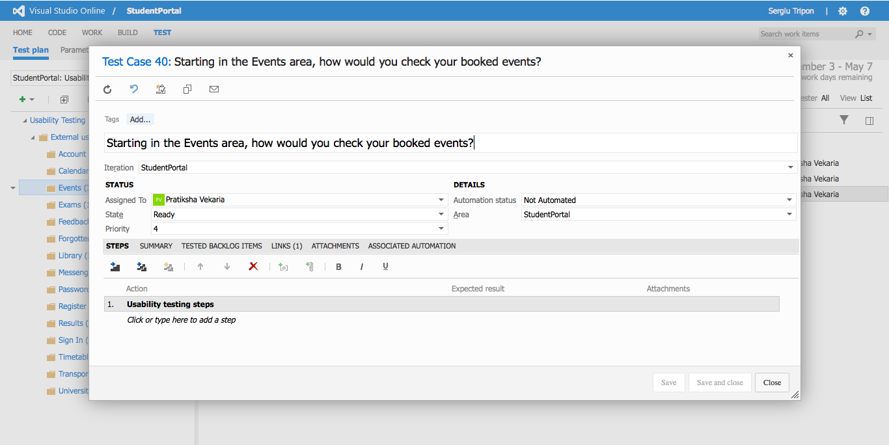

**Events** - detailed view of a test case

**Recording URL:** <https://student-portal.co.uk/usability-testing/?video=feedback>

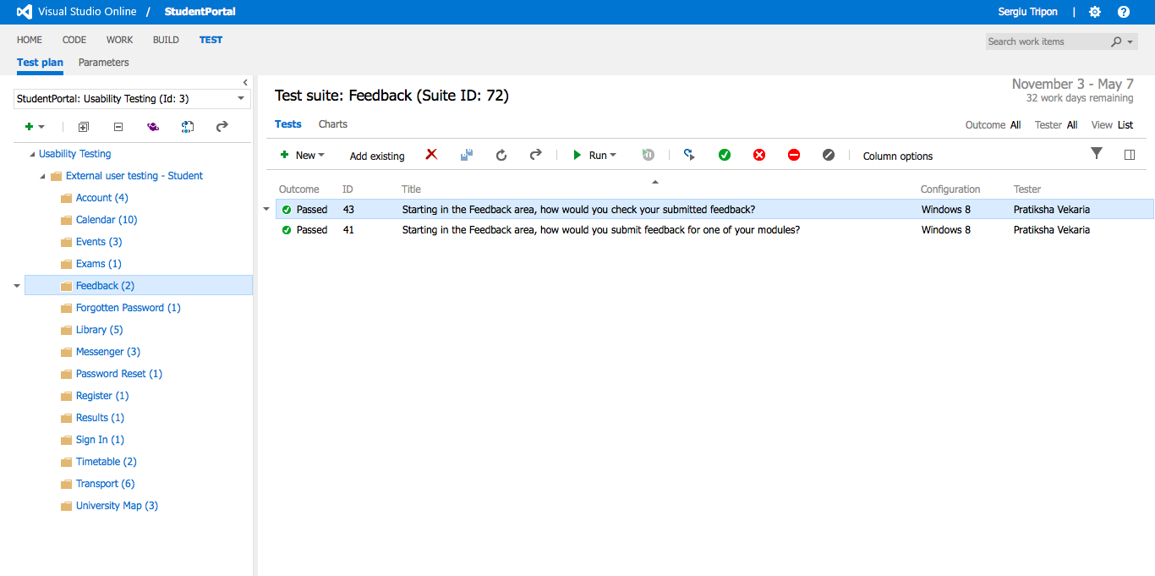

**Feedback** - overview of the test case(s)

**Recording URL:** <https://student-portal.co.uk/usability-testing/?video=feedback>

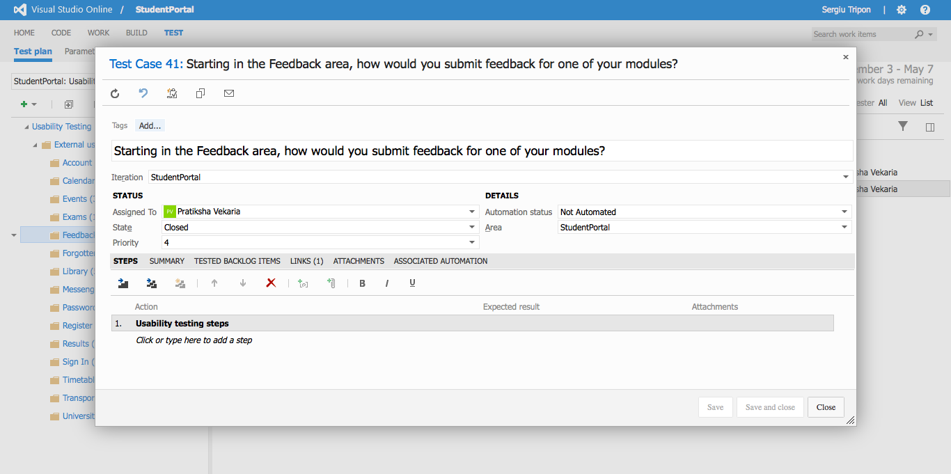

**Feedback** - detailed view of a test case

**Recording URL:** <https://student-portal.co.uk/usability-testing/?video=feedback>

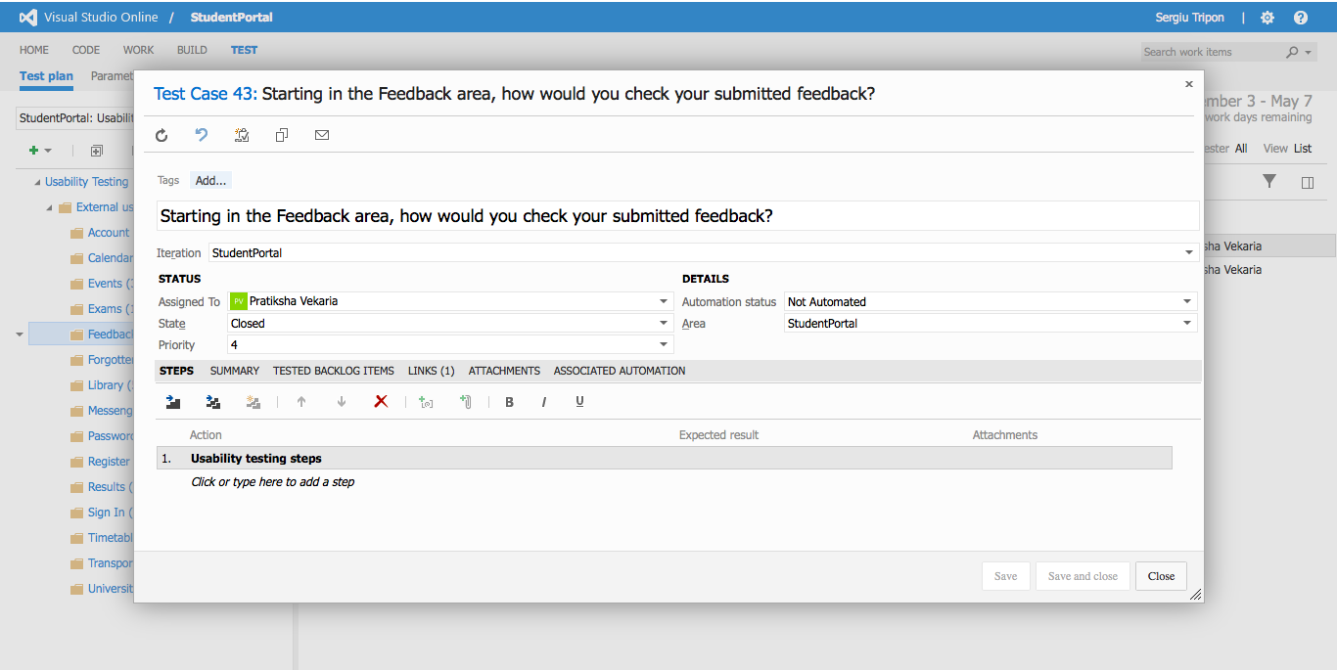

**Feedback** - detailed view of a test case

**Recording URL:** <https://student-portal.co.uk/usability-testing/?video=messenger>

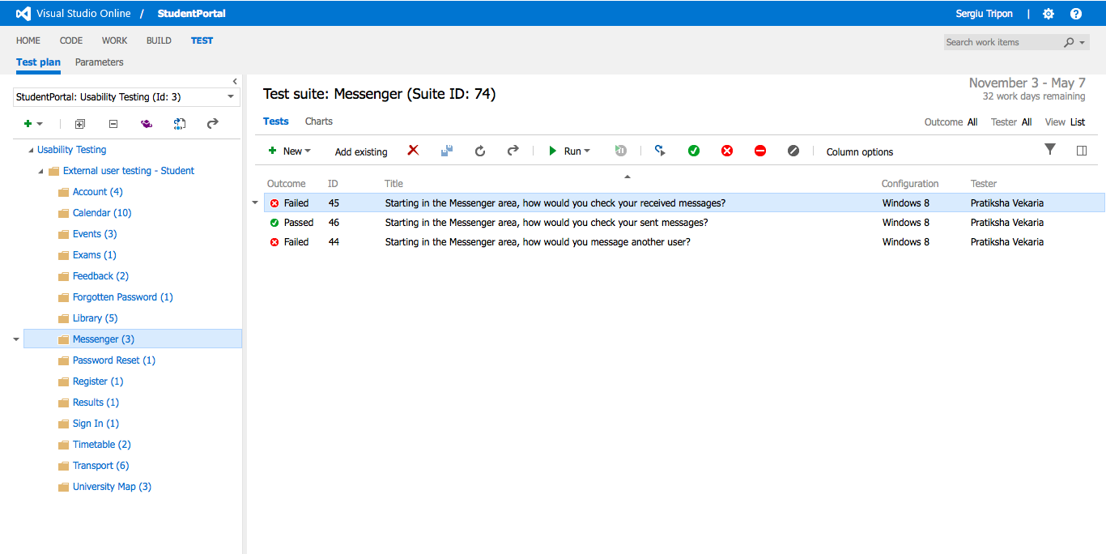

**Messenger** - overview of the test case(s)

**Recording URL:** <https://student-portal.co.uk/usability-testing/?video=messenger>

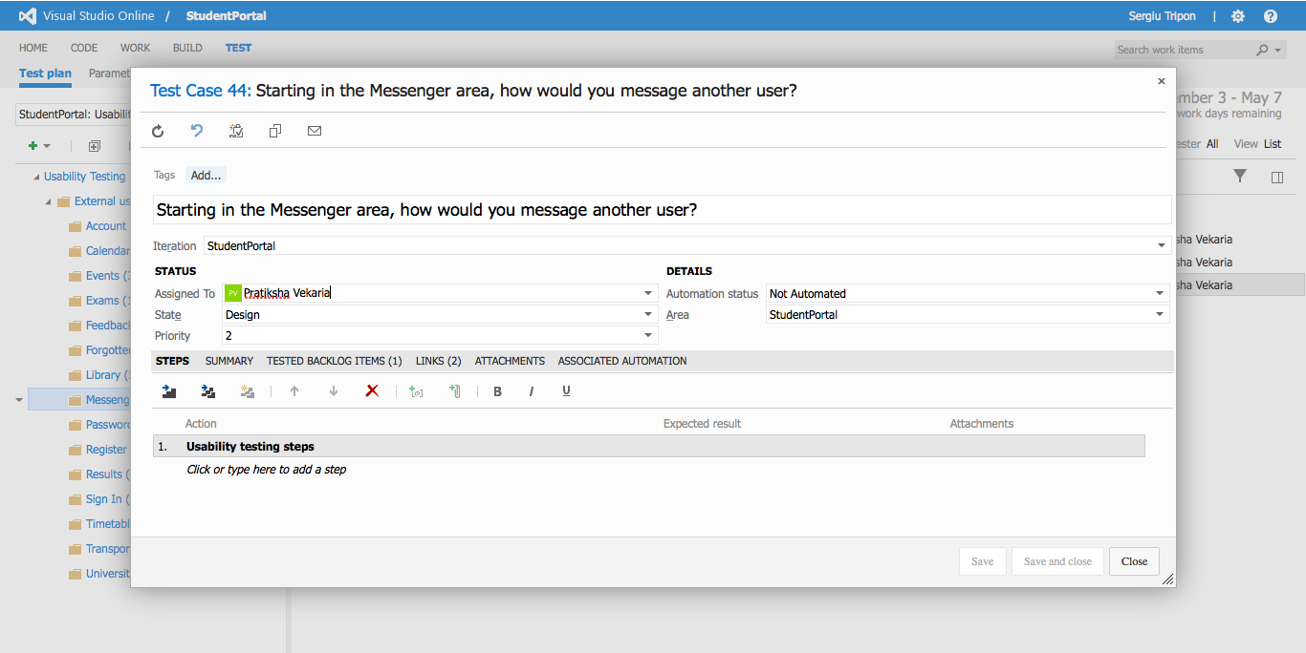

**Messenger** - detailed view of a test case

**Recording URL:** <https://student-portal.co.uk/usability-testing/?video=messenger>

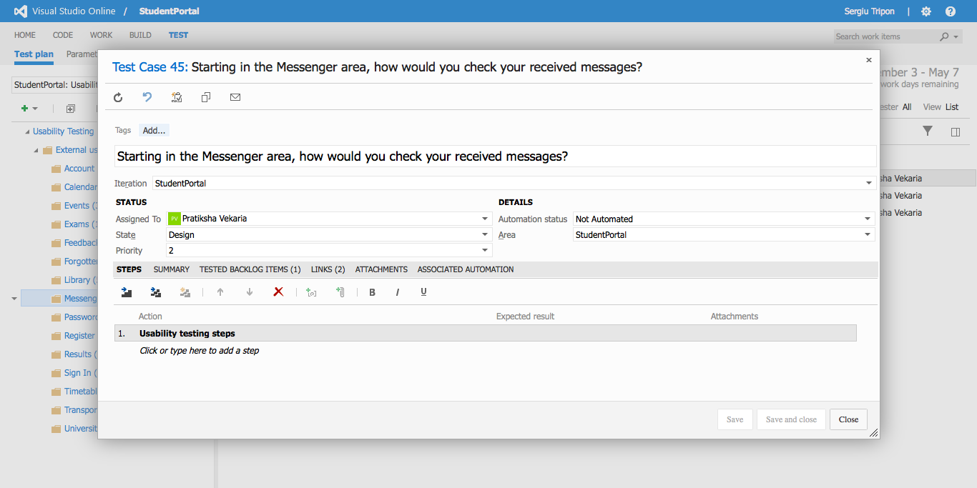

**Messenger** - detailed view of a test case

**Recording URL:** <https://student-portal.co.uk/usability-testing/?video=messenger>

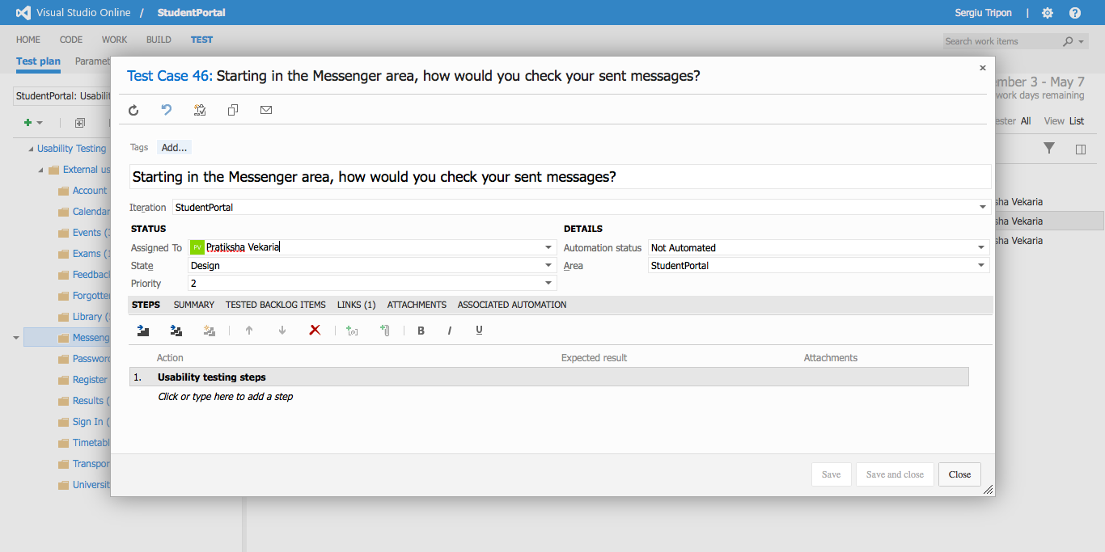

**Messenger** - detailed view of a test case

**Recording URL:** <https://student-portal.co.uk/usability-testing/?video=account>



**Account** - overview of the test case(s)

**Recording URL:** <https://student-portal.co.uk/usability-testing/?video=account>

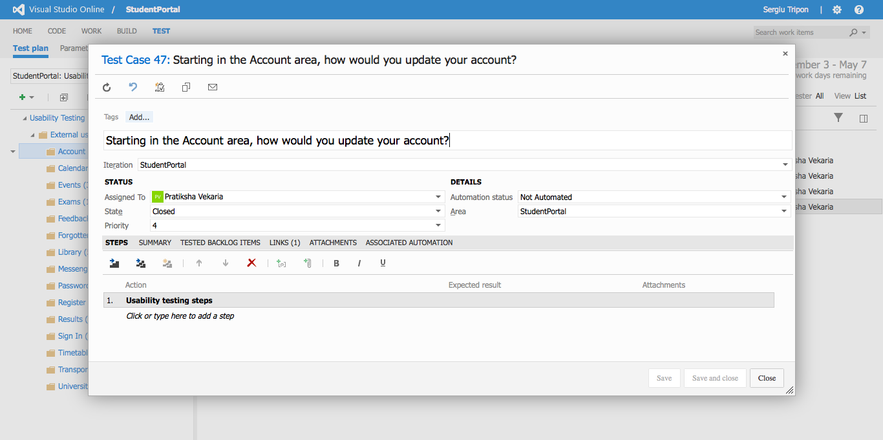

**Account** - detailed view of a test case

**Recording URL:** <https://student-portal.co.uk/usability-testing/?video=account>

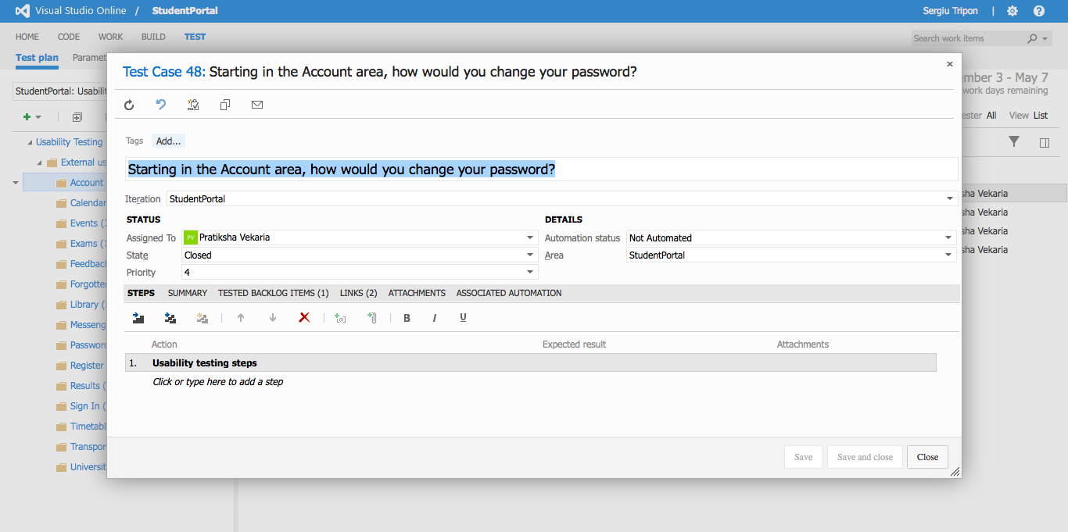

**Account** - detailed view of a test case

**Recording URL:** <https://student-portal.co.uk/usability-testing/?video=account>

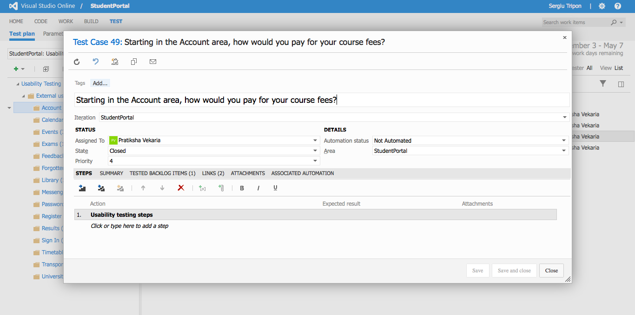

**Account** - detailed view of a test case

**Recording URL:** <https://student-portal.co.uk/usability-testing/?video=account>

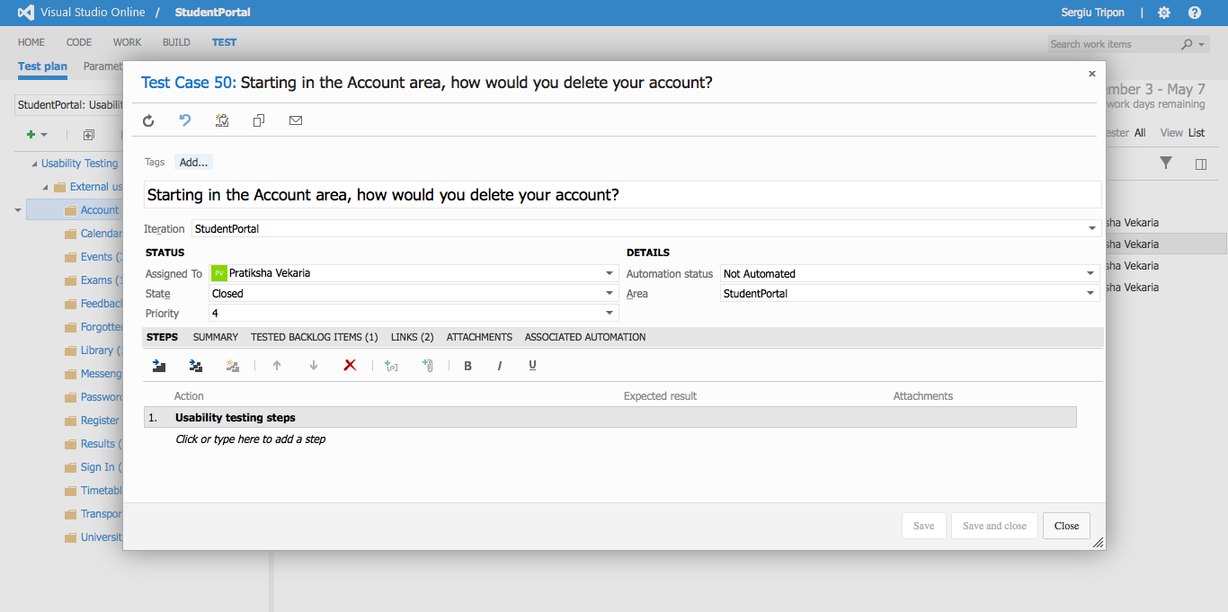

**Account** - detailed view of a test case

# Test results

**Recording URL:** <https://student-portal.co.uk/usability-testing/?video=account>

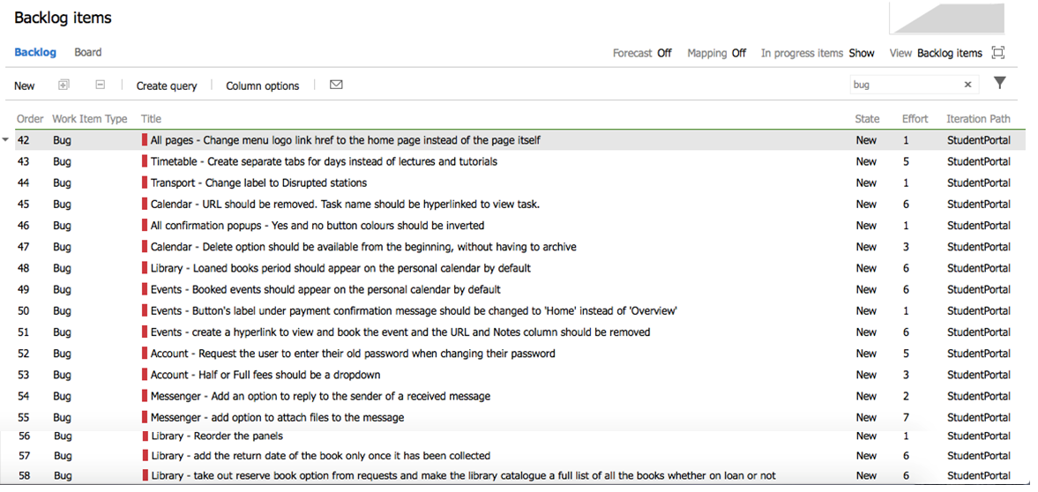

**Test results** - Overview

**Recording URL:** <https://student-portal.co.uk/usability-testing/?video=full-video>

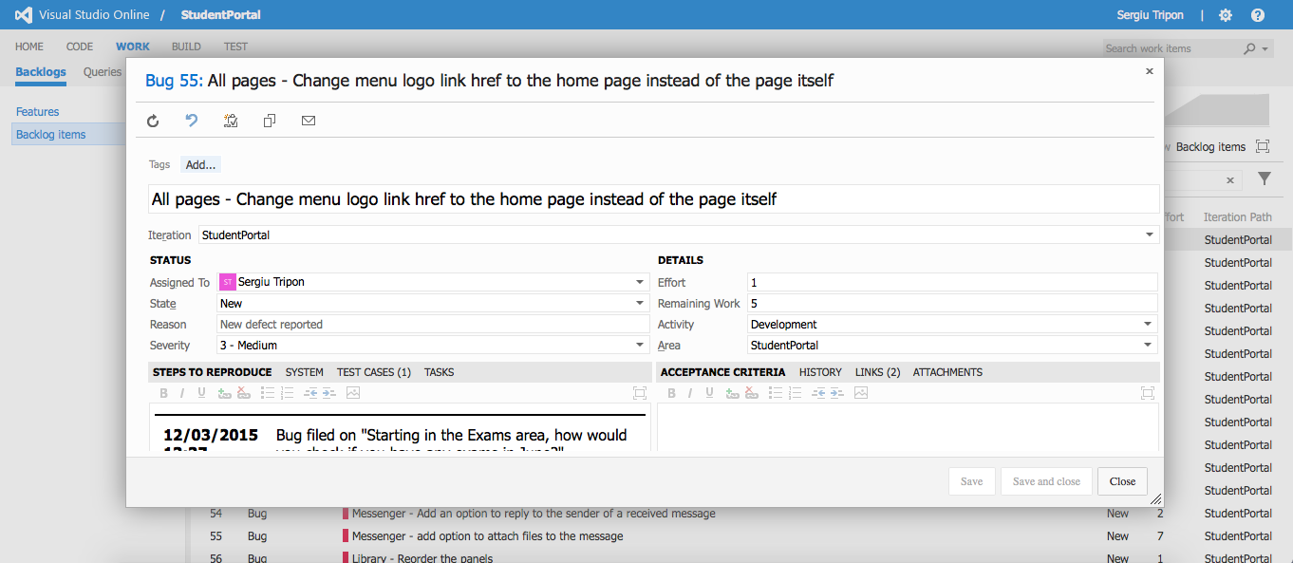

**All pages** - detailed view of a bug record

**Recording URL:** <https://student-portal.co.uk/usability-testing/?video=full-video>

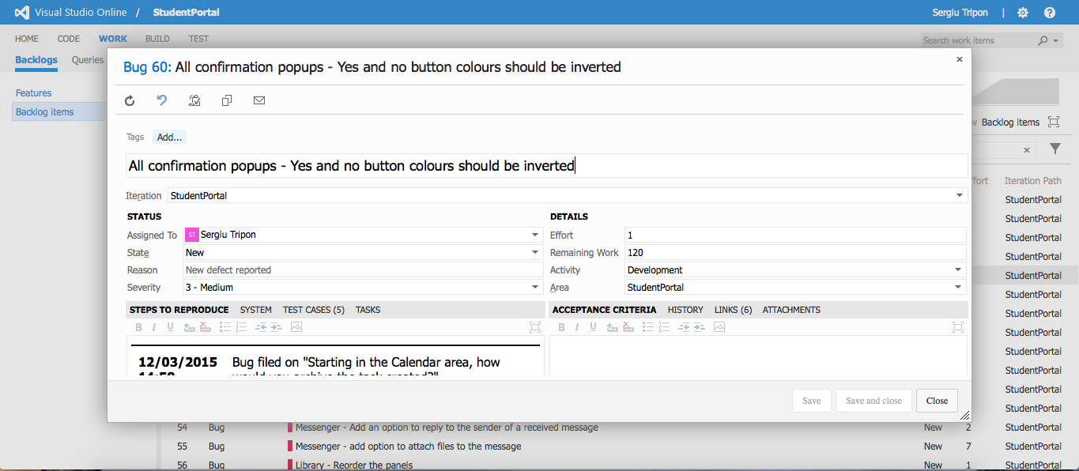

**All confirmation pop-ups** - detailed view of a bug record

**Recording URL:** <https://student-portal.co.uk/usability-testing/?video=timetable>

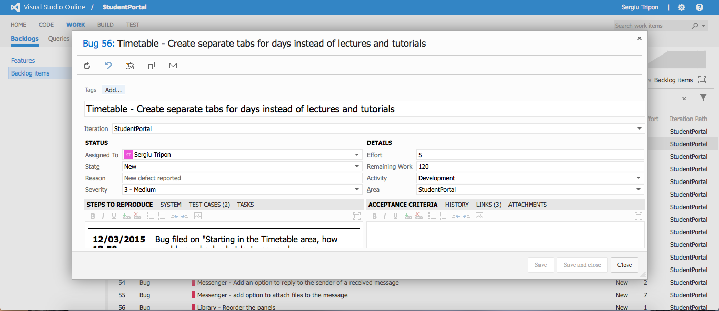

**Timetable** - detailed view of a bug record

**Recording URL:** <https://student-portal.co.uk/usability-testing/?video=transport>

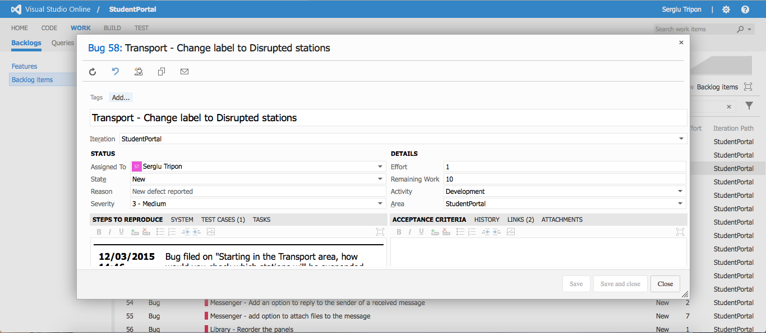

**Transport** - detailed view of a bug record

**Recording URL:** <https://student-portal.co.uk/usability-testing/?video=library>

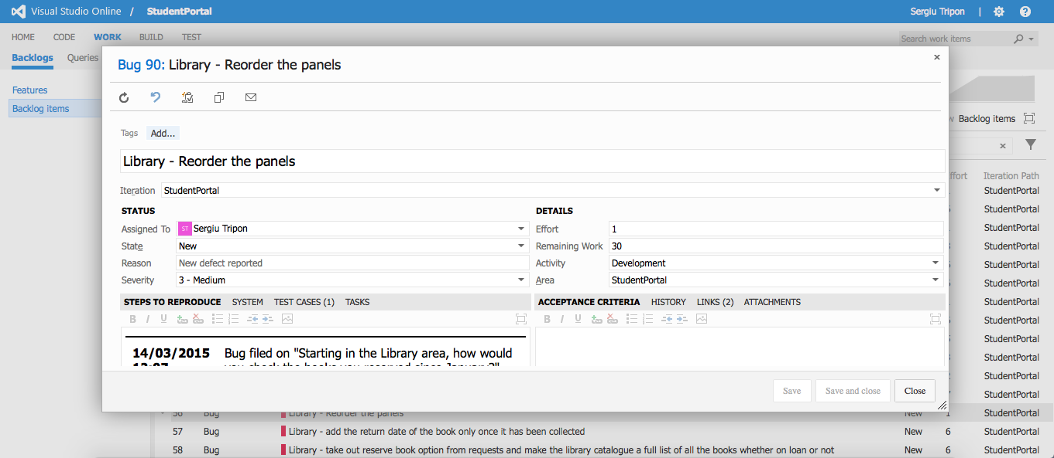

**Library** - detailed view of a bug record

**Recording URL:** <https://student-portal.co.uk/usability-testing/?video=library>

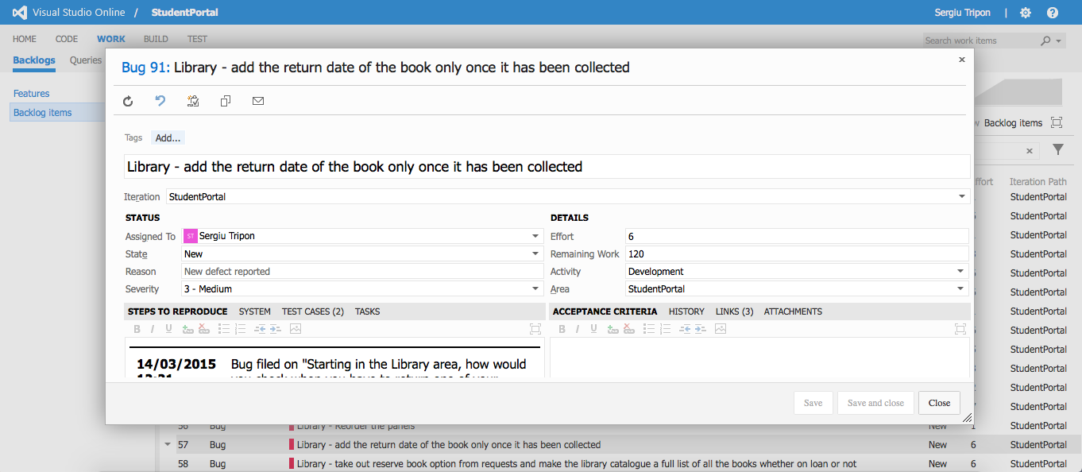

**Library** - detailed view of a bug record

**Recording URL:** <https://student-portal.co.uk/usability-testing/?video=library>



**Library** - detailed view of a bug record

**Recording URL:** <https://student-portal.co.uk/usability-testing/?video=library>

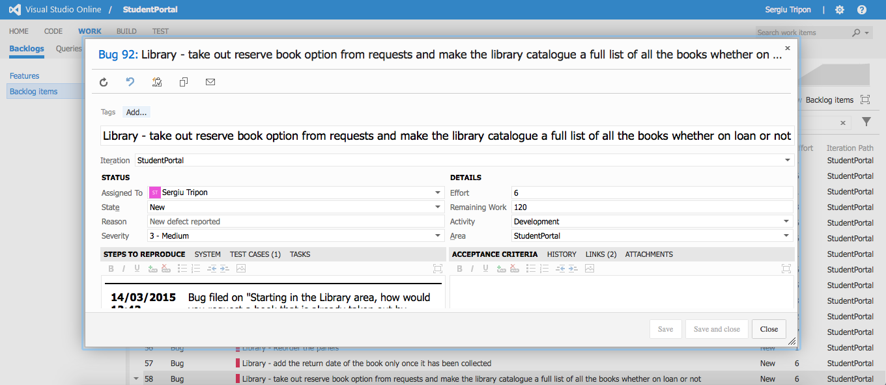

**Library** - detailed view of a bug record

**Recording URL:** <https://student-portal.co.uk/usability-testing/?video=library>

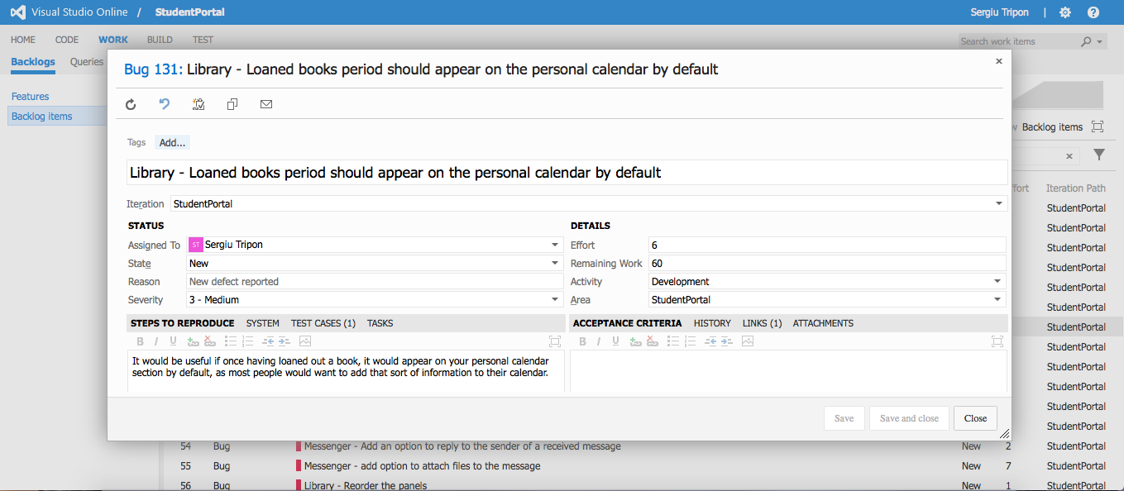

**Library** - detailed view of a bug record

**Recording URL:** <https://student-portal.co.uk/usability-testing/?video=calendar>

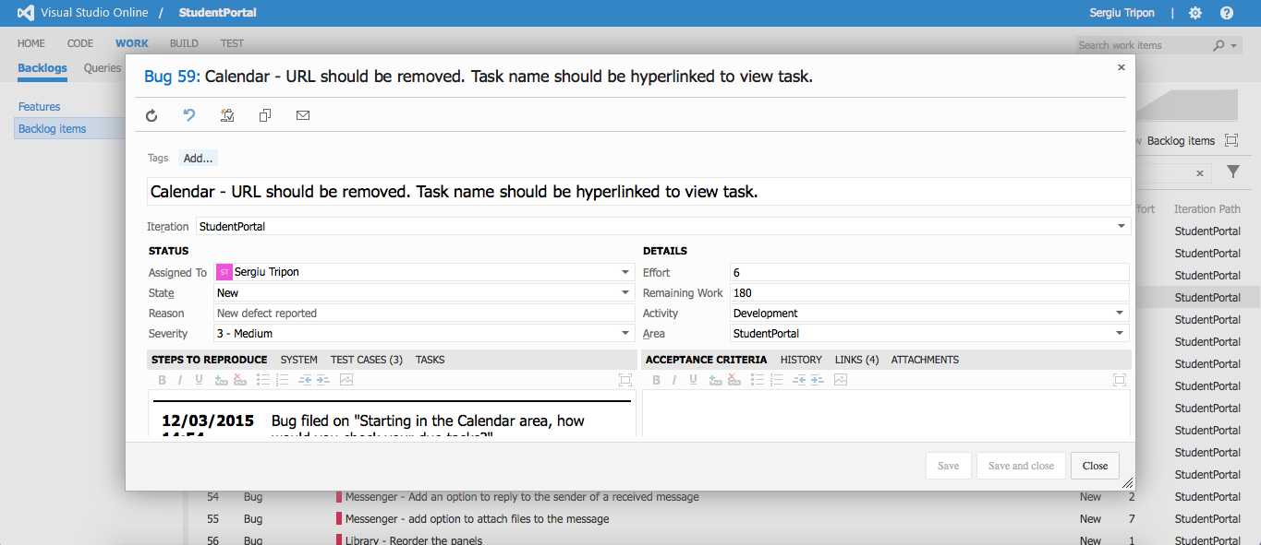

**Calendar** - detailed view of a bug record

**Recording URL:** <https://student-portal.co.uk/usability-testing/?video=calendar>

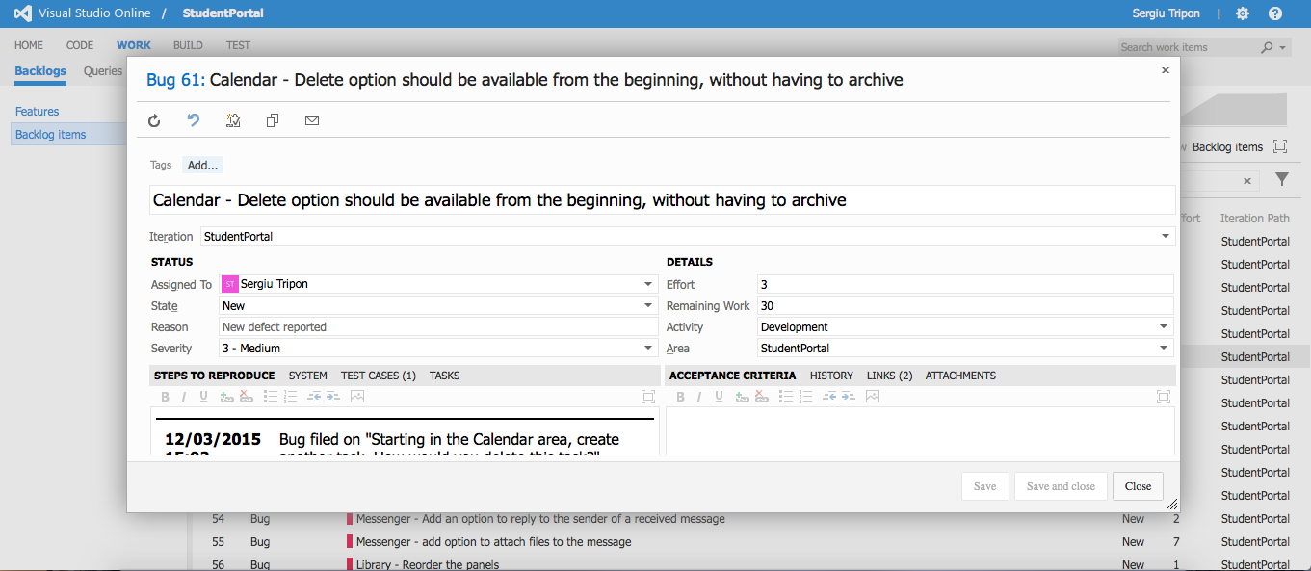

**Calendar** - detailed view of a bug record

**Recording URL:** <https://student-portal.co.uk/usability-testing/?video=events>

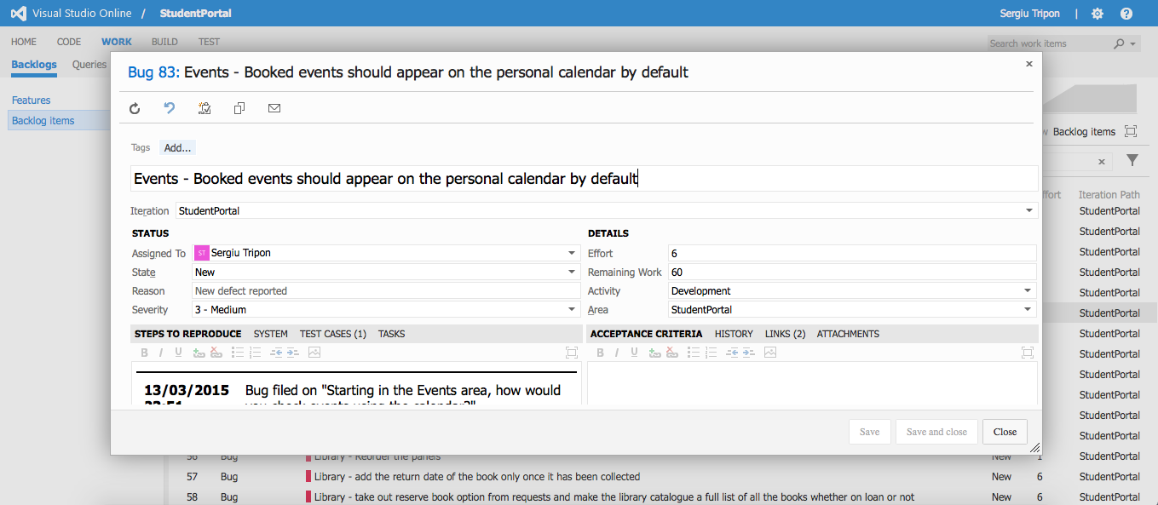

**Events** - detailed view of a bug record

**Recording URL:** <https://student-portal.co.uk/usability-testing/?video=events>



**Events** - detailed view of a bug record

**Recording URL:** <https://student-portal.co.uk/usability-testing/?video=events>

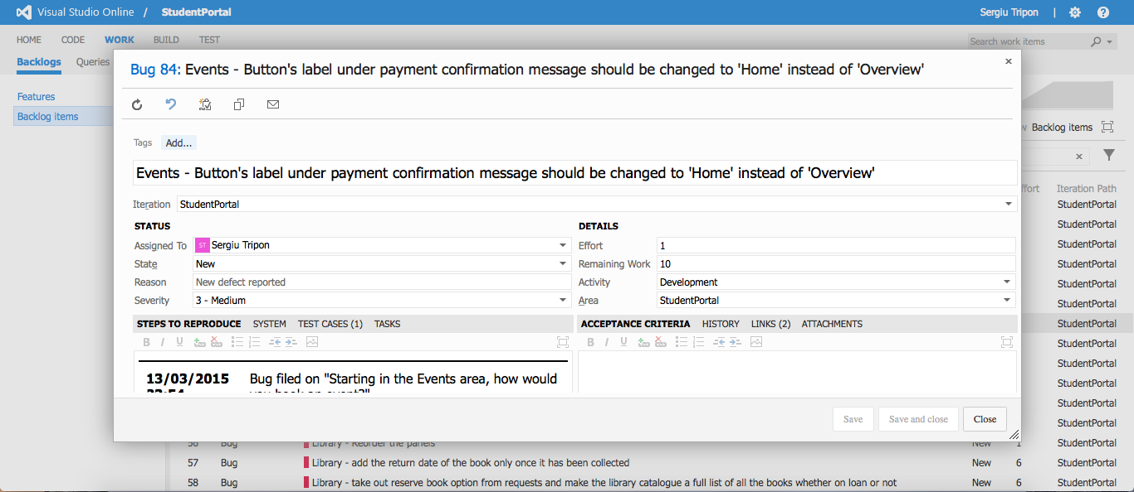

**Events** - detailed view of a bug record

**Recording URL:** <https://student-portal.co.uk/usability-testing/?video=events>

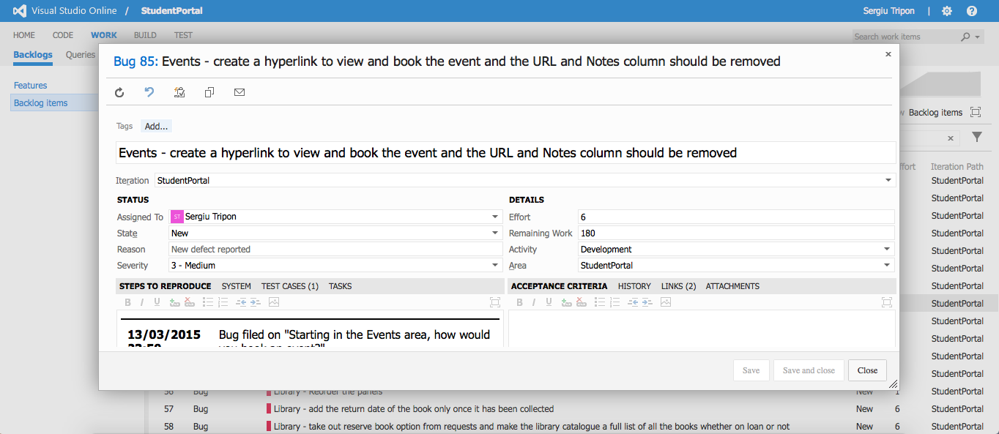

**Events** - detailed view of a bug record

**Recording URL:** <https://student-portal.co.uk/usability-testing/?video=messenger>

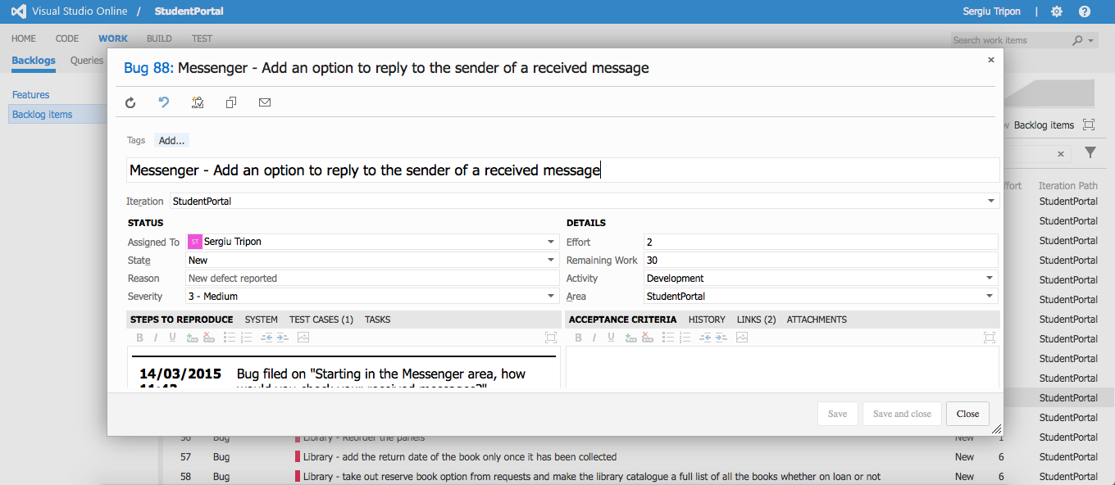

**Messenger** - detailed view of a bug record

**Recording URL:** <https://student-portal.co.uk/usability-testing/?video=messenger>

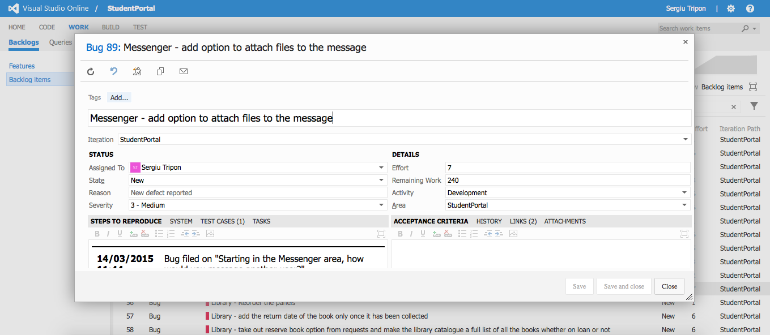

**Messenger** - detailed view of a bug record

**Recording URL:** <https://student-portal.co.uk/usability-testing/?video=account>

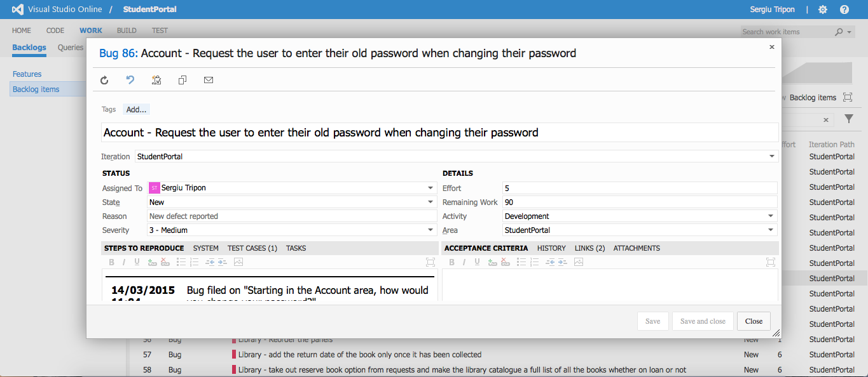

**Account** - detailed view of a bug record

**Recording URL:** <https://student-portal.co.uk/usability-testing/?video=account>

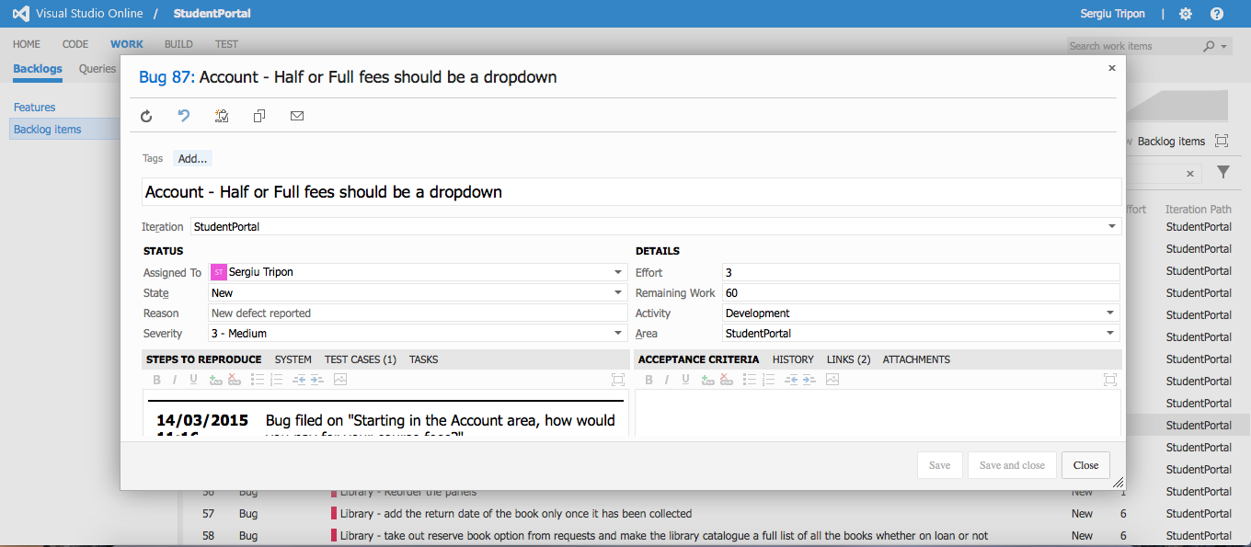

**Account** - detailed view of a bug record

